Bapuji educational Association

Bapuji Institute of Engineering and Technology, Davanagere

Department of Electronics & Communication Engineering

Report on innovations in teaching learning by faculty



Mr. Ganesh K

Assistant Professor

TAble of  
Contents

*1.* introduction 2

*2.* Innovative process for teaching learning 4

*3.* Usage of web resources 9

*4.* ANDROID APPLICATIONSfor interactive teaching 9

App name: Logic Simulator Pro 9

App name: Every CircuitSimulator 10

App name: 555 timer calculator 12

App name: Electrodroid 12

App name: FFT Spectrum Analyzer 14

App name: Grapher 15

App name: : FouSE-Fourier Series Expansion 16

*5.* Feedback about the innovative teaching learning process 18

Innovations in teaching learning by Faculty

## introduction

Modern technology enabled world has given an opportunity to make teaching learning more interactive, inclusive, inspiring and impactful. In engineering education, visualization plays a major role for better understanding of the concepts. Many interactive websites and Android applications help to fulfill this mission.

Innovative teaching learning method is most profound for today’s digital era. In the 1950's Benjamin Bloom developed his taxonomy of cognitive objectives, Bloom's Taxonomy. This categorized and ordered thinking skills and objectives. His taxonomy follows the thinking process. Blooms Digital Taxonomy is shown below.

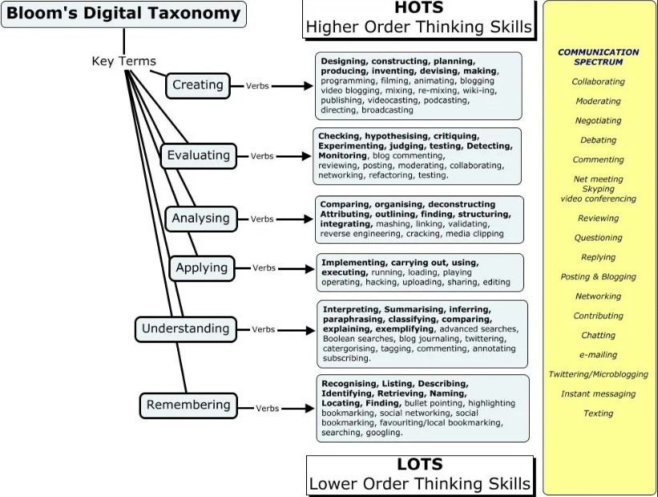

Figure Bloom's digital taxonomy

Mini projects will address all the levels of Blooms Digital Taxonomy.

Level 1 – Remembering

Students shall google search for suitable circuit and related material.

Level 2 – Understanding

Students shall interpret different websites, blogs and videos for building their mini project

Level 3 – Applying

Students shall apply the concepts taken from various sources to make circuits, build and operationalize.

Level 4 – Analyzing

Students shall engineer, reverse engineer the built circuit for achieving the set goal.

Level 5 – Evaluating

Students shall collaborate with group members and test the built circuit leading to implementation of collective intelligence.

Level 6 – Creating

Students shall make video of the presentation on working of the project, upload it to YouTube and share the link with friends through social media and submit the same to course instructor for grading.

All these levels are being addressed in the methods and processes designed for teaching learning discussed in subsequent sections.

## Innovative process for teaching learning

Figure Process of mini project evaluation followed for academic year 2018-19

Figure 1 shows one of the process followed for teaching first year engineering students for basic electronics subject. Syllabus mentions the below mentioned activities as a part of syllabus for 10 marks of CIE for Basic Electronics subject of 2018 scheme.

This activity has been carried out for the academic year 2018-19 and syllabus specifications are listed below.

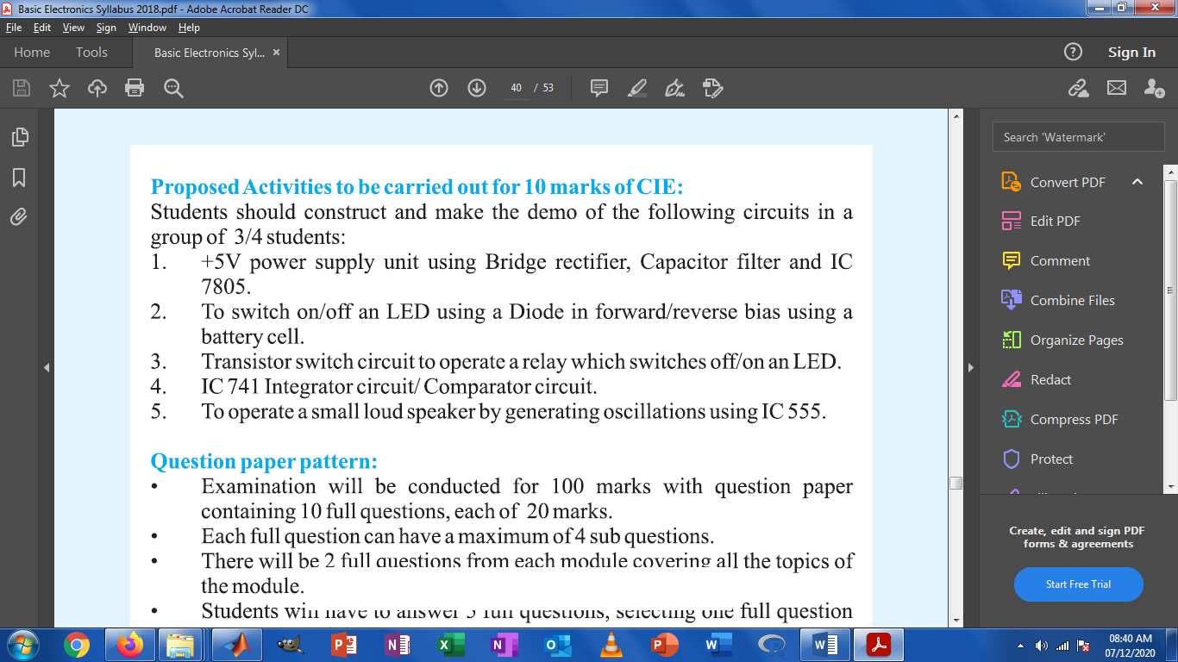

These five activities are assigned to students groups of size 4-5. Each group.

|  |  |  |  |  |
| --- | --- | --- | --- | --- |
|  | **Name of student** | **Group members USN and Name** | **Upload the video link of assignment** |  |
|  | Darshan M | 4BD18EC027 | <https://youtu.be/Kg_3wg3wU70> |  |
|  | <https://youtu.be/YW7jmhMaUDk> |  |
|  | <https://youtu.be/M-ocDQHuEaU> |  |
|  | <https://youtu.be/9KS4dwo5BCs> |  |
|  | <https://youtu.be/Kg_3wg3wU70> |  |
|  | Beeresh .p | 4BD18EC017 | <https://youtu.be/YW7jmhMaUDk> |  |
|  | Darshan M | Baldev.M.G -4BD18EC016 Beeresh.P-4BD18EC017 Darshan M-4BD18EC027 Anmoll- 4BD18CV004 | https://youtu.be/Kg_3wg3wU70 https://youtu.be/YW7jmhMaUDk https://youtu.be/9KS4dwo5BCs https://youtu.be/M-ocDQHuEaU |  |
|  | Nandeesh Y R | 4BD18EC034 Gurunandan K R 4BD18EC023 Chandan Kumar S R 4BD18CV011 Basavaraj V 4BD18EC026 Charanth Hosmath | <https://youtu.be/Kv52nstkqIc> |  |
|  | Nandeesh Y R | Gurunandan K R. 4BD18EC034 Chandan Kumar. 4BD18EC023 Basavaraj V. 4BD18CV011 Charanth hosmath 4BD18EC026 | https://youtu.be/Kv52nstkqIc https://youtu.be/CHHdUqV9XeE https://youtu.be/WBMdqcrAdlc https://youtu.be/XGsMyCzDkH0 https://youtu.be/f8P_8V9zLSk |  |
|  | Jhansi P M | 4BD18EC046 Jhansi P M 4BD18EC013 asfiya khanum 4BD18EC025 chandana P 4BD18EC039 Harshini S B 4BD18CV014 Bhavana k m 4BD18CV020 Deepa T S | <https://youtu.be/sqJ9bt76V48> |  |
|  | Ashwini Savanur | Anuradha kolekar: 4BD18EC009 Afreen M Y: 4BD18CV001 Archana M A: 4BD18CV006 Ashwini N S: 4BD18CV009 Banashree P: 4BD18CV010 | <https://youtu.be/VBY3AbnMhMM> |  |
|  | Nandeesh Y R | Nandeesh Y R. 4BD18EC062 Gurunandan K R. 4BD18EC034 Chandan Kumar. 4BD18EC023 Basavaraj V. 4BD18CV011 Charanth Hosmat. 4BD18EC026 | <https://youtu.be/YHHgDIB6xOs> |  |
|  | Ashwini.k.p | Dikshitha R P-4BD18CV021 Akhila.Y.S-4BD18EC007 | <https://youtu.be/cfjDK-4RZgE> |  |
|  | Nandeesh Y R | Nandeesh Y R. 4BD18EC062 GURUNANDAN K R 4BD18EC034  CHANDAN KUMAR 4BD18EC023  BASAVARAJ V. 4BD18CV011  CHARANTH HOSMAT 4BD18EC026 | <https://youtu.be/YHHgDIB6xOs> |  |
|  | Anusha H S | BhoomikaKM4BD18EC021.  Bhoomika V K 4BD18EC020.  Anusha N 4BD18EC011.  Anusha H S 4BD18EC010.  Anusha G E 4BD18CIV005 | <https://youtu.be/MQWtLY7Xmec> |  |
|  | Ashwini.k.p | Ashwini.K.P-4BD18EC015 Dikshitha. R.P-4BD18CV021 Akhila.Y.S-4BD18EC007 | <https://youtu.be/cfjDK-4RZgE> |  |
|  | Bharath V N -4BD18EC019 | Akash B E -4BD18EC006 Bharath V N -4BD18EC019 Amruthbalu -4BD18EC008 Ajay P Hiregowdar -4BD18EC004 Dinesh yadav -4BD18CV022 H K Varun -4BD18CV026 | <https://youtu.be/Mtd1JmvE8TE> |  |
|  | Ambika | Ambika:4BD18CV003 Aishwarya:4BD18EC003 Chandana:4BD18EC024 | <https://youtu.be/PT3GMKy8qac> |  |
|  | Chandana.P.R. | Geetha.R.G-4BD18CV025 Chandana. P.R-4BD18CV015 Bhagya lakshmi.C.H-4BD18EC018 Akarsha. K.M-4BD18EC005 | <https://youtu.be/vEtFq-ofi6Y> |  |
|  | Ambika | Ambika:4BD18CV003 Aishwarya.s:4BD18EC003 Chandana.D:4BD18EC024 | <https://youtu.be/PT3GMky8qac> |  |
|  | Brunda billal | Brunda 4BD 18EC022 | <https://youtu.be/yPnHoE6YleM> |  |
|  | Aishwarya S | Aishwarya S-USN-4BD18EC003 Chandana D-USN-4BD18EC024 Ambika N L-USN-4BD18CV003 | <https://youtu.be/PT3GMky8qac> |  |
|  | Arun N S | Arun N S 4BD18EC012 Abhishek RS 4BD18EC002 Ashish V 4BD18EC014 Abhishek K 4BD18EC001 Dheeraj R 4BD18EC028 | <https://youtu.be/0agjItsuZ6I> |  |

Snapshot of one of the video assignment uploaded to YouTube is shown in the picture below in

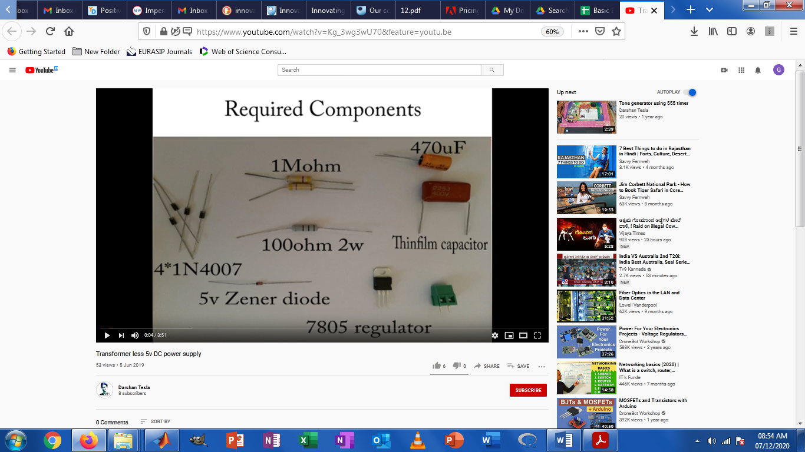

Figure 5V power supply by Darshan uploaded to YouTube

Course outcomes of Basic Electronics(Subject Code 18ELN15/25) are listed below.

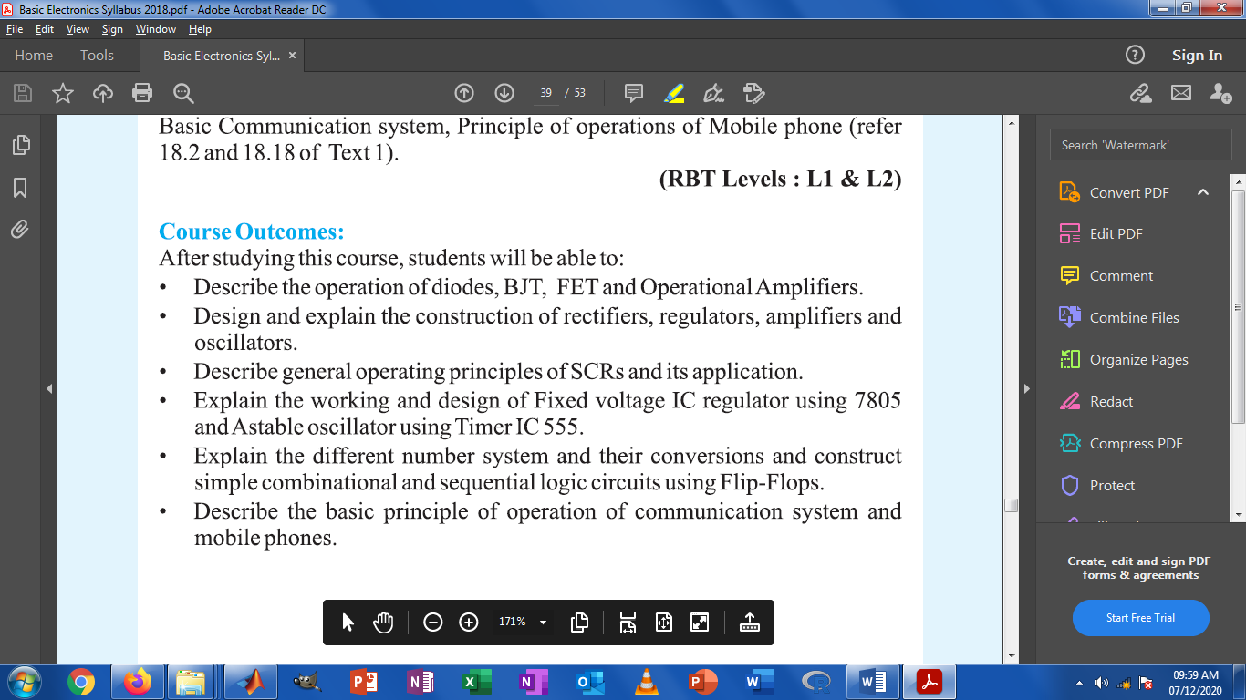

The activity carried out is in correlation with 4 outcomes out of 6 outcomes.

## Usage of web resources

Many universities across the globe have provided open course wares to reach out to global students. Even many industries and hobbyists publish content which is useful for the students for exploration.

List of websites used for innovative teaching learning process.

* [www.allaboutcircuits.com](http://www.allaboutcircuits.com)
* [www.electronicsclub.info](http://www.electronicsclub.info)
* [www.electronicshub.org](http://www.electronicshub.org)
* [www.engineersgarage.com](http://www.engineersgarage.com)
* [www.ecetutorials.com](http://www.ecetutorials.com)

## ANDROID APPLICATIONSfor interactive teaching

Android applications play major role in teaching learning since the exponential growth in the access to smart phones in this decade. Each of the student in this study population was having smart phone, mostly Android. Smart phones can be effectively used for electronics circuit simulation, accessing datasheets, for electronic calculations and so on.

In subsequent section, different Android applications demonstrated to students have been listed. Playstore links for these applications were shared in in Whatsapp group and students were motivated to use for better learning.

### Logic Simulator Pro iconApp name: Logic Simulator Pro

**Type: Educational and Simulation applications**

Logic Simulator Pro is one of the Android Logic simulator for logic gate, combinational and sequential circuit simulation. It has been used to teach logic gates, Flip Flops, Multiplexers, and Decoders. Visual building of circuit helps the student to better understand the concepts.

### App name: Every CircuitSimulator

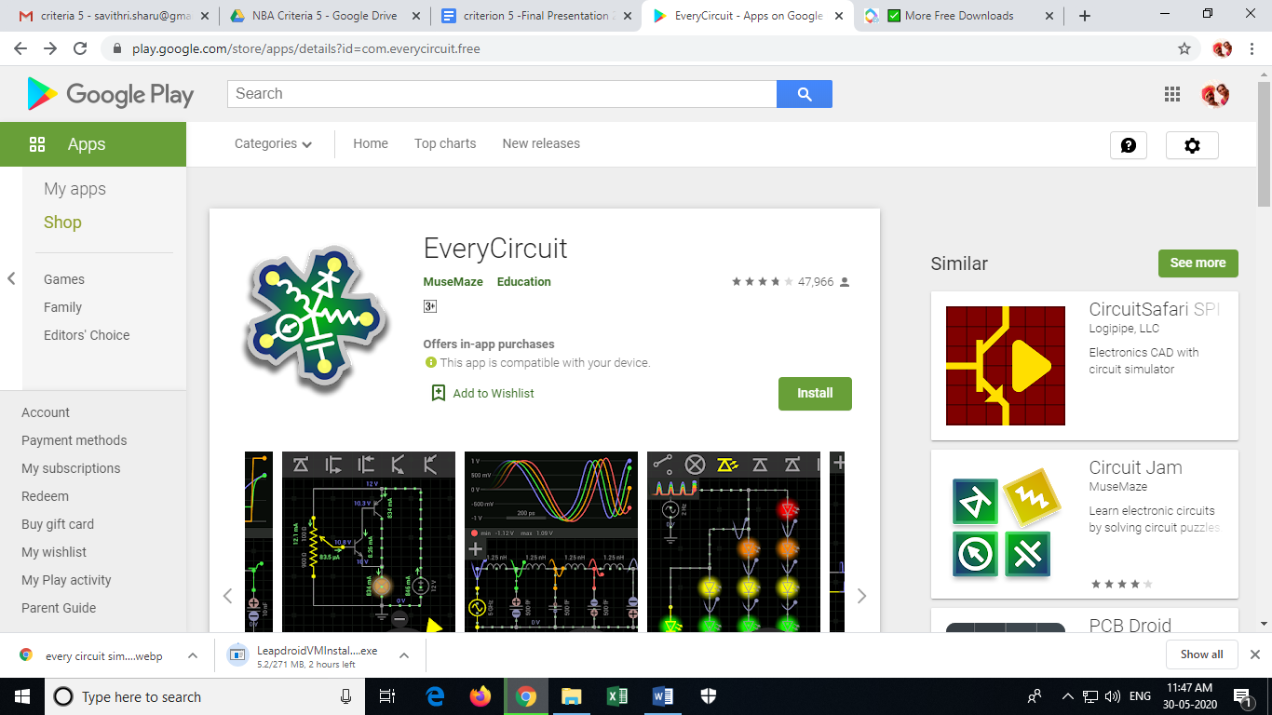

**Application**: Android Apps

**Type**: Educational and Simulation applications

EveryCircuit has custom-built simulation engine optimized for interactive mobile use, serious numerical methods, and realistic device models. In short, Ohm's law, Kirchhoff's current and voltage laws, nonlinear semiconductor device equations, and all the good stuff is there

**Features:**

Growing public library of community circuits

Animations of voltage waveforms and current flows

Animations of capacitor charges

Analog control knob adjusts circuit parameters

Automatic wire routing

Oscilloscope

Seamless DC and transient simulation

Single play/pause button controls simulation

Saving and loading of circuit schematic

Mobile simulation engine built from ground-up

Shake the phone to kick-start oscillators

Intuitive user interface

**Components**:

Sources, signal generators

Controlled sources, VCVS, VCCS, CCVS, CCCS

Resistors, capacitors, inductors, transformers

Voltmeter, amperemeter, ohmmeter

DC motor

Potentiometer, lamp

Switches, SPST, SPDT

Push buttons, NO, NC

Diodes, Zener diodes, light emitting diodes (LED)

MOS transistors (MOSFET)

Bipolar junction transistors (BJT)

Ideal operational amplifier (opamp)

Digital logic gates, AND, OR, NOT, NAND, NOR, XOR, XNOR

Relay

555 timer

Counter

7-segment display and decoder

### App name: 555 timer calculator

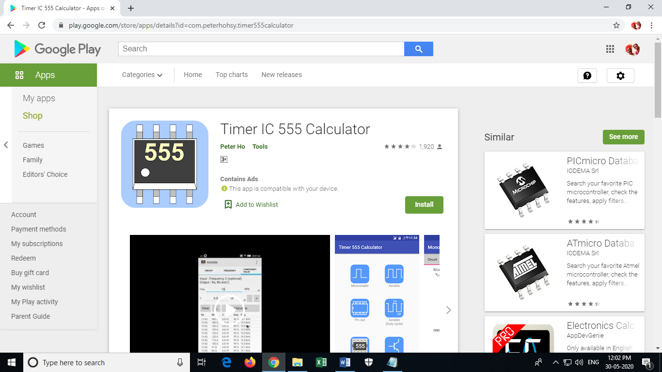

**Type**: Educational and Simulation applications

This app is used to calculate monostable and astable circuit

Features:

1. Calculate monostable circuit

2. Calculate frequency of astable circuit

3. Calculate component values of monostable and astable circuit. Save component values in CSV file (Excel file)

### App name: Electrodroid

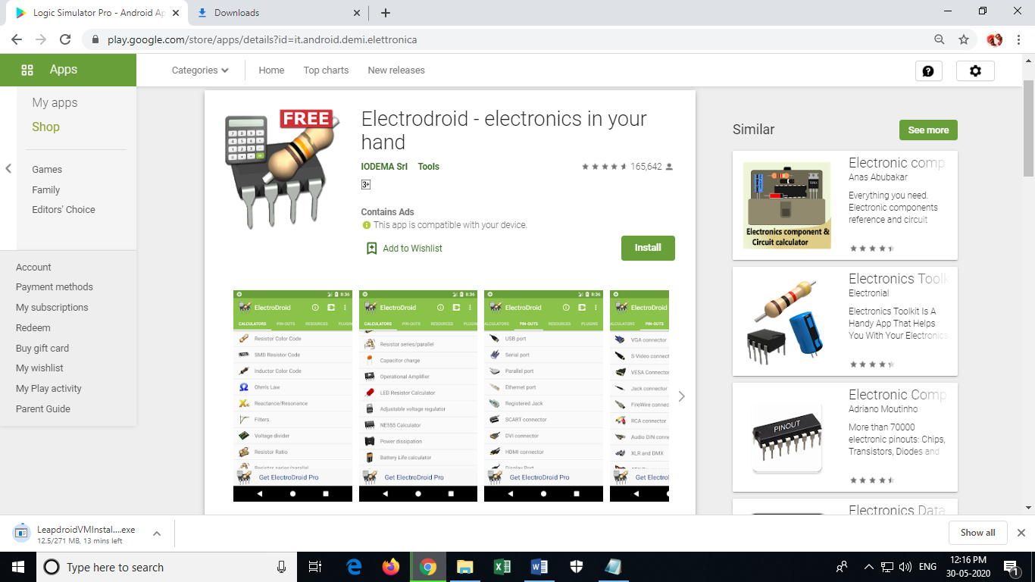

**Type**: Educational and Simulation applications

ElectroDroid is a simple and powerful collection of electronics tools and references

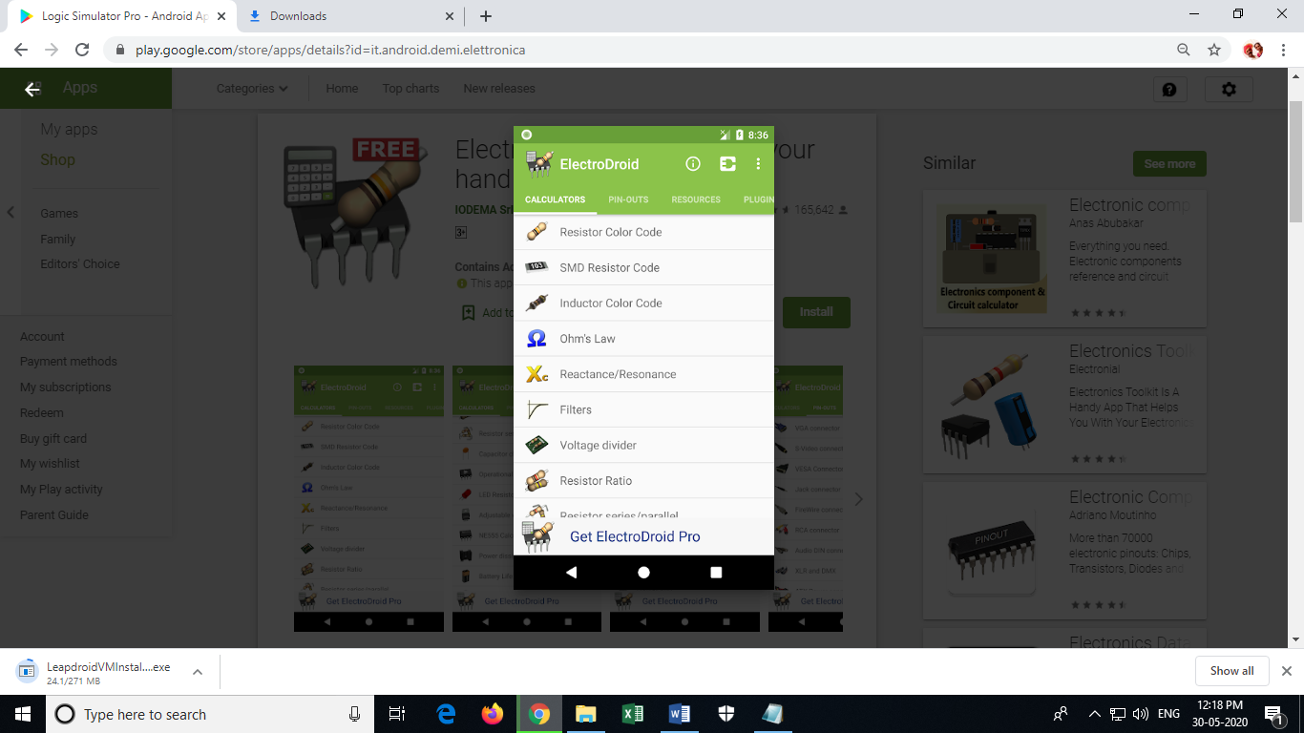 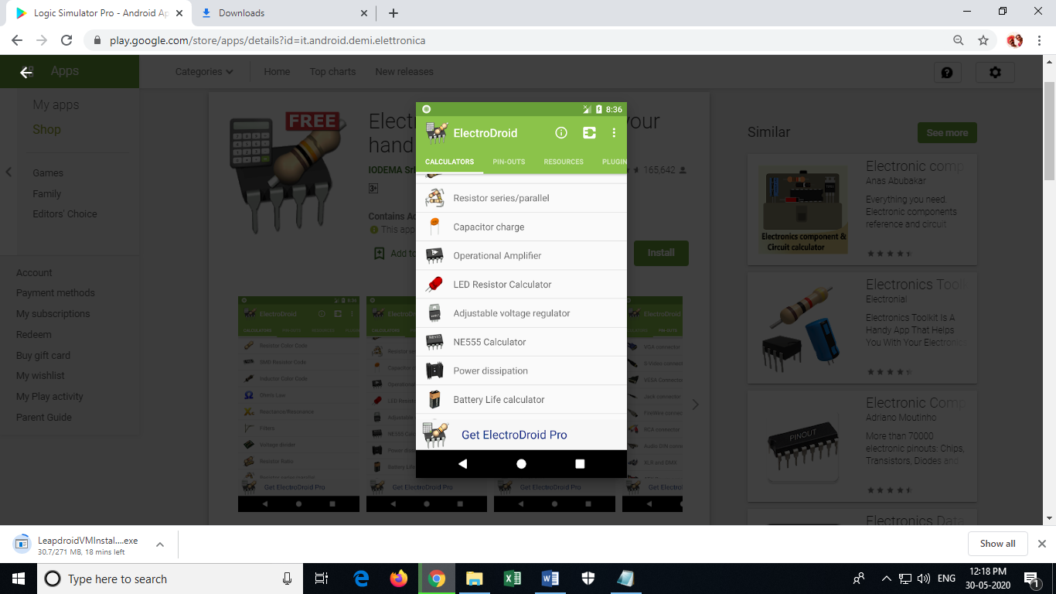 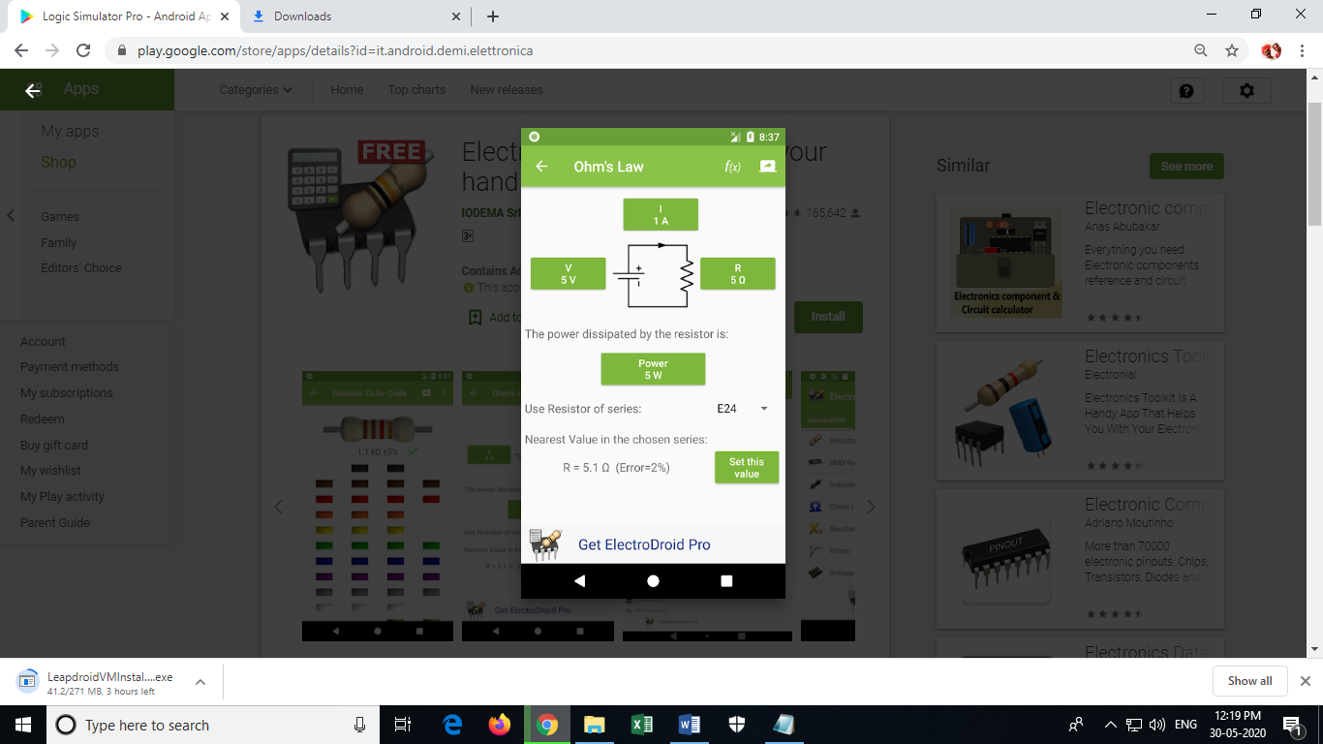

The app includes:

• Resistor color code decoder (3-6 bands)

• SMD Resistor Code

• Inductor color code decoder

• Ohm’s law calculator

• Reactance/Resonance calculator

• Voltage divider

• Resistors ratio, value/series/parallel

• Capacitor charge calculation

• Operational amplifier

• LED resistor calculator

• Adjustable voltage regulator/LM317 calculator

• Heat dissipation

• Battery Life calculator

• Inductor design tool

• Voltage Drop calculator

• PCB Trace Width calculator

• Simple Filters calculator

• NE555 calculator

• Power Calculator

• Decibel Converter

• Frequency Converter

• Analog-Digital Converter

• Y-Δ Transformation

### App name: FFT Spectrum Analyzer

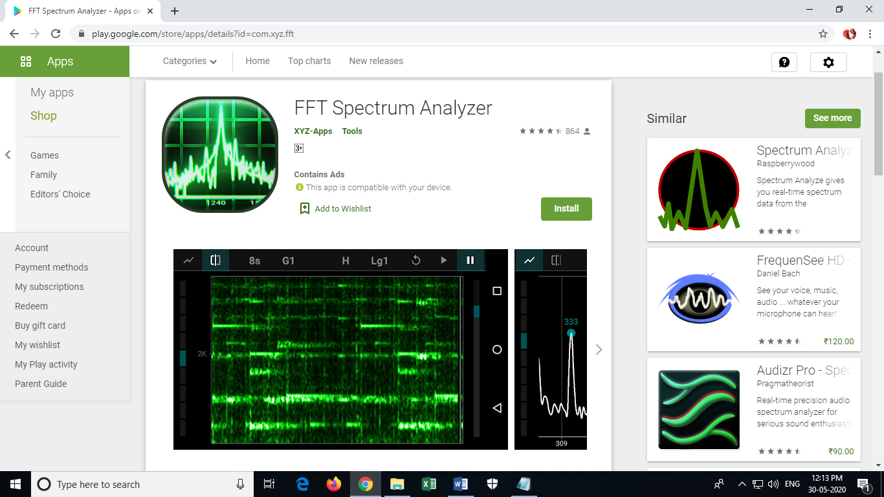

**Type**: Educational and Simulation applications

This is an interactive android application which displays spectrum of the audio signal. User can view the spectrum of audio spectrum of the sound picked up by the mobile microphone. Option to select number of points of FFT, different windowing techniques are present. User can also set the range of frequencies to view.

**Features**

- Spectrum analyzer

- Graph view

- Waterfall view

- Adjustable frequency range

- Adjustable scales (linear, logarithmic, etc.)

- Different window functions

- Hold button

- Microphone input

- Detect main frequencies

### App name: Grapher

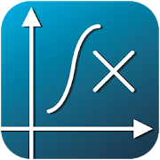

**Grapher** is a fast and effective equation plotter, capable of drawing any function, solving equations and calculating expressions. A wide range of predefined functions is available, including trigonometric & hyperbolic functions, polar coordinates, differentiation and more. Anything you type will be processed and displayed instantly by a powerful math engine, in both 2D and 3D modes. Furthermore, functions can reference each other by their name.

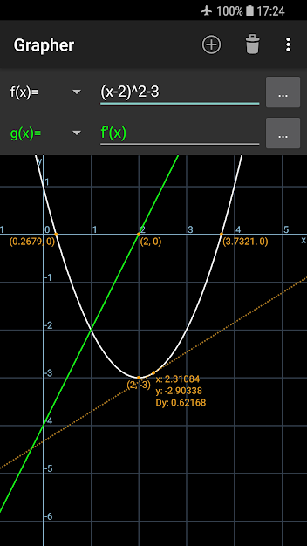

Figure Drawing of a function using Grapher app

**Features of Grapher**

**Curve types**  
• Function (e.g. parabola, sine wave)  
• Polar (e.g. rose, spiral)  
• Parametric (e.g. ellipse, Lissajous) on the xy-plane or rθ-plane  
• Implicit equation (e.g. conic sections)  
• Implicit inequality (e.g. half-plane)  
• 3D function (e.g. paraboloid)  
• 3D parametric curve (e.g. helix)  
• 3D parametric surface (e.g. sphere, hyperboloid)  
  
**More features**  
• Equation solver (numerical)  
• Find roots, extrema and intersections with other functions  
• Functions can reference each other, e.g. g(x)=2*f(x+1)  
• Custom math keyboard  
• Auto-detect input type  
• User variable support for both numbers and functions  
• Adjustable parameter range (for cartesian, polar & parametric curves)  
• Input history  
• Plot up to 28 graphs at once  
• Differentiation (numerical)  
• Trace graph  
• Capture screenshots

### App name: : FouSE-Fourier Series Expansion

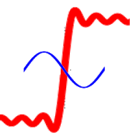

This app helps in the learning of Fourier series expansions. It has an easy-to-use, friendly interface, and can be viewed as a tool to help undergraduate students test and assess the Fourier series expansions on typical set of signals, such as:  
-- Sawtooth;  
-- |\sin| (full wave rectified);  
-- Half sin (half wave rectified);  
-- Square;  
-- Triangle;  
-- Parabolic (t^2).  
Some of its main characteristics include the ability for the students to control the total approximation error and the number of terms/harmonics used in the expansion.

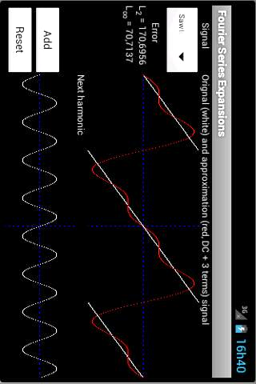

Figure Simulation of Fourier Series

## Feedback about the innovative teaching learning process

Feedback has been taken about innovations in teaching learning process. A sample template has been given below.

