Nandeesh.R.S.  Assistant Professor  TX Department,  BIET. | Address  Department of Textile Technology  Bapuji Institute of Engineering and Technology Shabnur Road Davangere: 577004  Mob: +91 8892398246  Email: 24nandeesh@gmail.com | 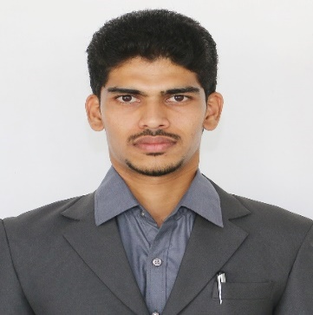

Objective:
To build career in an organization, where I can get the opportunities to prove my abilities by accepting challenges, fulfilling the organizational goal and climb the career ladder through continuous learning and commitment.

Research Interests:
- Textile Fibres
- Textile Testing

Academic Profile:

Visvesvaraya Technological University, Belagavi 2017-2018

Master of Technology (M.Tech), Textile Technology, Bapuji Institute of Engineering and Technology, Davangere

Visvesvaraya Technological University, Belagavi 2010-2011

Batchelor Technology (B.Tech), Textile Technology, Bapuji Institute of Engineering and Technology, Davangere

Work Experience:
- PAGE INDUSTRIES LIMITED (JOCKEY) in Fabric Sourcing & QC Department BANGALORE – 560068

Teaching Experience
Assistant Professor
Assistant Professor from August 03 2020 to till date in the department of Textile Technology, BIET

Subjects Handled
Textile Fibre, Textile Testing, Technical Textile, Social connectivity and Responsibility

Additional Role @ BIET
- NBA Criteria-5 Team member (Department Level)
- IA Marks Coordinator (Department Level)
- Crash Course Coordinator (Department Level)
- NAAC- Criteria -4 Coordinator (Department Level)
- Supervisor for college Admission for 2020-21 (Institute Level)
- Alumni Coordinator (Department Level)
- UHV Coordinator (Department Level)
- Sports Coordinator (Department Level)
- Department Library In charge

EXTRA CURRICULAR ACTIVITIES:

- Magazine secretary BIET, Davangere in 2011&2012
- Acted as a Judge Committee coordinator in DAVANA 2015 conducted by BIET, Davangere.
- Participated in Power lifting, Weightlifting, Best physic competition in VTU Sports.
- Acted as a stage committee coordinator in VTU fest 2014 conducted by BIET, Davangere
- Acted as TEXCREATIVE committee member 2014&2015
- Coordinator of TEXCREATIVE 2016
- Participated in competition of High Jump, Walking Race in VTU Athletic meet 2018

INDUSTRIAL TRAINING:
- Undergone In plant Training on production process of CASUAL SHIRTS at “AQUARELLE INDIA PRIVATE LIMITED” BANGALORE for 2 weeks
- Undergone In plant Training on production process of Apparel Manufacturers at “SRI SAI CREATIONS” DAVANGERE for 14weeks

Seminars/Workshops Attended
- Inculcating Universal Human Value in Technical Education 5 Days Online 26th to 30th July 2021 AICTE
- Advance Ecological Techniques in Textile Chemical Processing for sustainable Development 7 Days online 23rd to 29th April 2021 KSRT
- Innovation in Textiles-Products and Processes 2 Days Online 2nd & 3rd Sep 2021 DKTE
- Universal Human Value and Professional Ethics 2 Days 29th & 30th Nov 2022 BIET
- Implementation of National Education Policy-2020 2 Days 10th 11th Dec2021 BIET
- Best practices for New Education policy(NEP)-2020 in Higher Education Institution 1 Day 21st February-2023
- Interface of IPR in academics and Entrepreneurship 2 Days 2nd & 3rd March 2023

Nandeesh.R.S.
Assistant Professor
Department of Textiles, BIET.
Davangere: 577004

