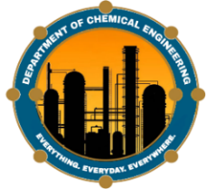
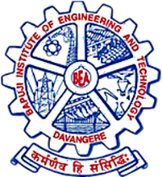
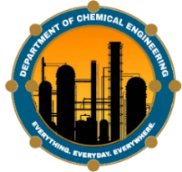
BAPUJI EDUCATIONAL ASSOCIATION (R)
BAPUJI INSTITUTE OF ENGINEERING AND TECHNOLOGY
Post Box No.325, Davangere-577004.Karnataka-India
DEPARTMENT OF CHEMICAL ENGINEERING
Web site: www.bietdvg.edu. Email:bietchemical@gmail.com

Annual News Letter (2021-2022) Volume V
CHEMICAL
POSTS & GLOBE
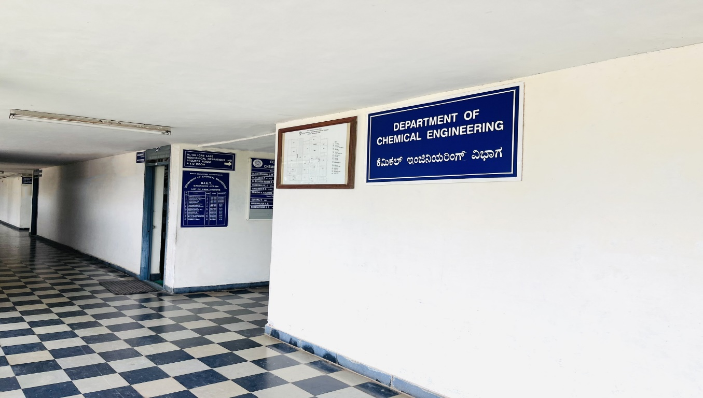

- A journey of an excellence from creativity to productivity
Contents of the issue:
- Vision, Mission, PEO’s and PSO’s
- About the Department
- Message from HOD’s Desk
- Association Activates
- Faculty Interaction
- Student Interaction
- Distinguished Alumni
- Grandaunts List of 2016-2020
“Education is not the learning of facts, but the training of minds to think"
- Albert Einstein

VISION OF THE INSTITUTE
"To be center of excellence recognized nationally and internationally, in distinctive areas of engineering education and research, based on a culture of innovation and invention."
MISSION OF THE INSTITUTE
"BIET contributes to the growth and development of its students by imparting a board based engineering education and empowering them to be successful in their chosen field by inculcating in them positive approach, leadership qualities and ethical values."
VISION OF THE DEPARTMENT
"To train and generate efficient manpower required for effective management of core / allied industries, have a thrust for innovation, undertaking need based research who contributes to Global knowledge and wealth."
MISSION OF THE DEPARTMENT
M1: To offer a quality and efficient undergraduate program in Chemical Engineering required for successful professional career.
M2: To produce graduates who have ability for creative thinking and an urge for continued learning.
M3: To practice sustainability and promote eco-friendly processes which benefit engineering profession and society.
PROGRAM EDUCATIONAL OBJECTIVES OF DEPARTMENT
PEO1: Ability to advance professionally in their chosen career, wherein they apply their professional and generic skills inculcated during their training.
PEO2: Exhibit leadership qualities and collaborate successfully while working in multidisciplinary teams to tackle multifaceted problems.
PEO3: Ability to design scale up and regulate systems which meet specific needs economic environment public safety
PROGRAM SPECIFIC OUTCOMES (PSO'S) OF DEPARTMENT
PSO1: Demonstrate the professional and generic skills needed to apply the principles of chemical engineering in solving real- time problems, acquired during their course of training.
PSO2: Able to undertake independent research and engage themselves in life-long learning.
PSO3: Play a lead role and exhibit economic, professional and ethical values at their professional career.

ABOUT THE DEPARTMENT

Department of Chemical Engineering, BIET, with an intake of 30 students, under Kuvempu University was established during the academic year 1996-97. At present, the department is permanently affiliated to VTU Belgaum. The department is recognized as Research Center and offers Ph. D. in Chemical Engg. Department is accredited by “The Institution of Engineers India, Kolkata” and two times accredited by National Board of Accreditation (NBA), New-Delhi. Department is housed in a permanent building, which has seven laboratories, two lecture halls, a seminar hall, one drawing hall, five faculty rooms and a departmental reading room cum library with a built-up area of 1000 sq. meters and a fixed capital investments of around Rs. 2.00 Crores.
Department has 1 Professor, 1 Associate Professor and 4 Assistant Professors. Three faculty members have PhD degree and guide research students. Department is actively involved in research activities and received research grant to the tune of 65 lakhs from Govt. agencies. Development of bio fuels like bio diesel, bio ethanol from biomass, pyrolytic oil from municipal solid wastes. VGST, Govt of Karnataka has sanctioned Rs 30 lakhs under CISE Grants, Sophisticated equipment like Super critical Extractor and FTIR have been imported at the cost of 27 lakhs. Average pass percentage of the students is 93% and the department students have bagged 16 University ranks including 3 first ranks. 52 student's projects have been sponsored by KSCST with a total financial grant of around 1.5 Lakhs. Many of our students have qualified in GATE, GRE and GMAT examinations and are pursuing higher studies in India and abroad. The department has very good placement record with 90% of students placed in on/off campus recruitments. Students of the department are working in reputed companies like TCS, MCF, BIOCON, CIPLA, BASF, Reliance, Jindal, Syngene, etc. Department conducts many events for the benefit of the students. Every year National Level Students’ symposium “Chemexcel” is being conducted. In addition guest lectures/invited talks, industrial visits, in-plant training and group discussions are regularly arranged along with sports and cultural competitions.

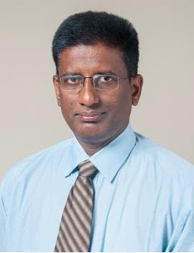
News Letter Committee
Patrons
Dr. Shamanur Shivashankarappa
MLA, Hon. Secretary, BEA
Sri S.S. Mallikarjun
Joint Secretary, BEA
Advisory Board
Prof. Y Vrushabhendrappa
Director, BIET
Dr. Arvind H B
Principal, BIET
Dr. C M Kalleshappa
Professor & Head
Dr. G P Desai
Professor & Dean Public Relation
Editor
Smt. Shashikala K J
Assistant Professor
Mr. Srinidhi R Kulkarni
Assistant Professor

Associate Editor
Dr. Praveen Kumar D G
Associate Professor
Sri. Amaranth P C
Assistant Professor
Student Editors
Ms. Aikya Rai
Mr. Nagadarshan G S
Ms. Jessica
Ms. Keerthana R Y

Message from HOD's Desk:
Dear students and faculty members, it is mater of great pride that we are bringing out second newsletter of chemical engineering department. Technological and scientific advancement are taking place at very fast pace in the world. In such an environment industry demands highly qualified, skilled and efficient engineers who contribute to the needs of industry and society. Right now, we are in the midst of corona virus pandemic and the disease has devastated not only India but the whole world. The pandemic has caused the economic devastation, loss of livelihood of the people and severe labour migration problems in India. In spite of all the hardships, let us hope that the situation will improve and we will come out of this crisis very soon. Though the lock down has slowed the wheels of economy, demand remain very high for chemical engineering students. Department is fortunate to highly qualified staff with 3 faculty holding PhD degrees. We have very good research infrastructure for both students and faculty. We express our gratitude for our alumni for their service to the department and helping recruit our students.

Dr. C. M. Kalleshappa
Professor and Head
Department of Chemical Engineering

ASSOCIATION ACTIVITIES
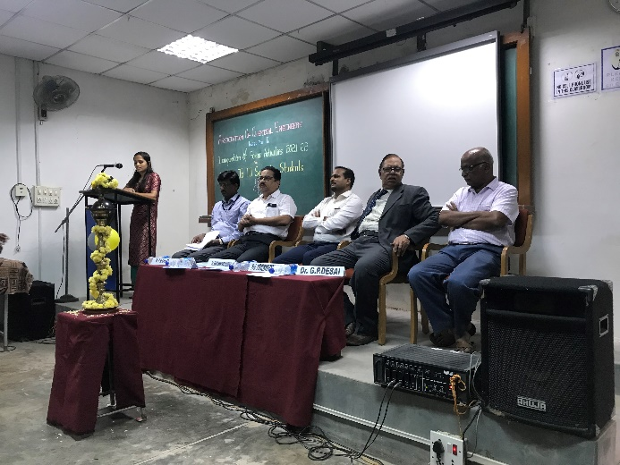
- Inauguration of Association of Chemical Engineers for the academic year 2021-2022 and welcome for the III semester students was organized on 19th November 2021 at 10:30 A M. Our Alumni Sri Santhosh kumar Guddad, Biocon Biologics , Banglore , Prof. Y. Vrushabhendrappa, Director and Principal Dr. H B Aravind was the chief guest for the function and Dr. C. M. Kalleshappa was the president of the function.
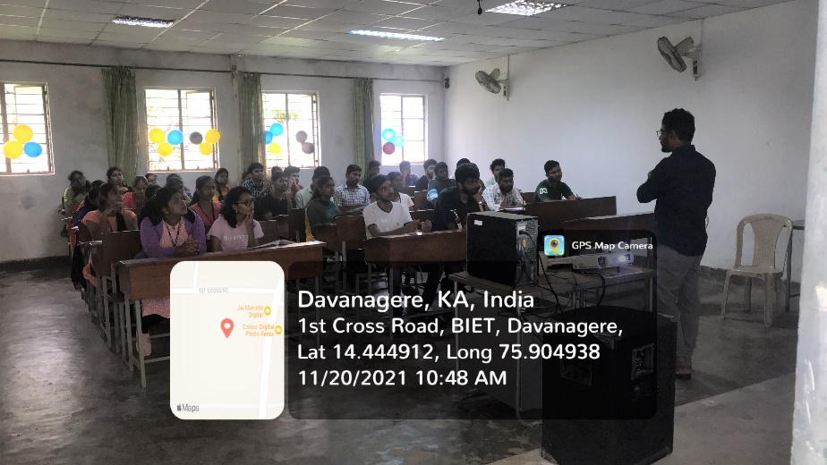
- Invited talk on “Resume writing and Information on job sites” by our Alumni Basavangowda, Data Analyst Swiggy, Bangalore.

- Department organized Five days hands on training workshop on “UNISIM Process Simulation Software” in association with ISTE and IEI local center davangere. Mr. Babukannan sankar, Process simulation Engineer, Honeywell Chennai, was our resource person.

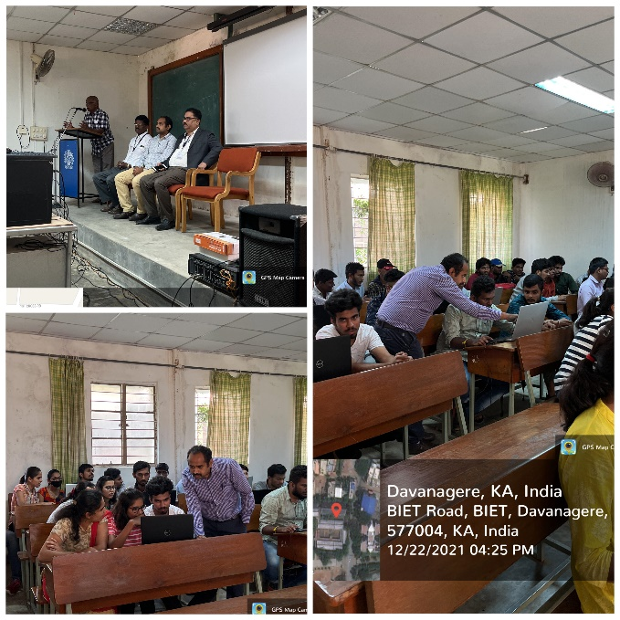
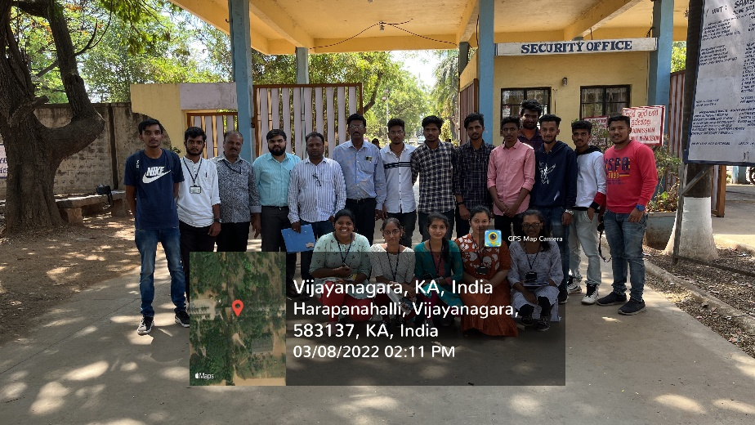
- Industrial Visit for 3rd Semester students to M/s Samson distilleries and Sam Agro Biotech, Duggavati on 08th March 2022.
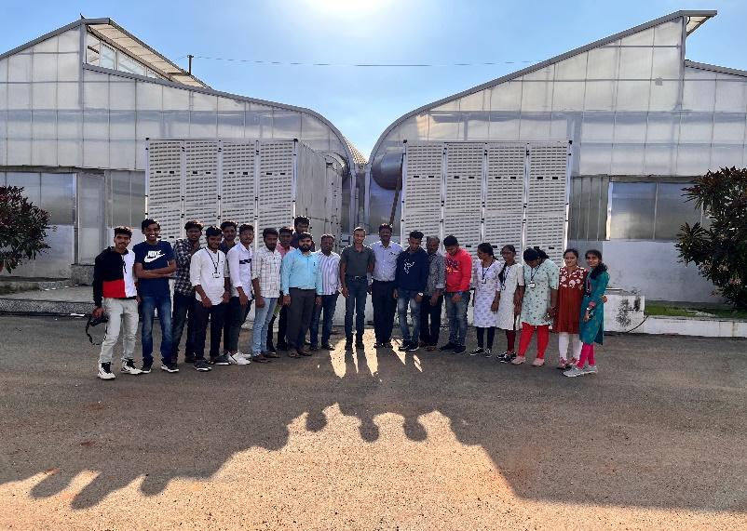
- Debate Competition on “Does modern social media make people less socially active” on 06-05-2022.
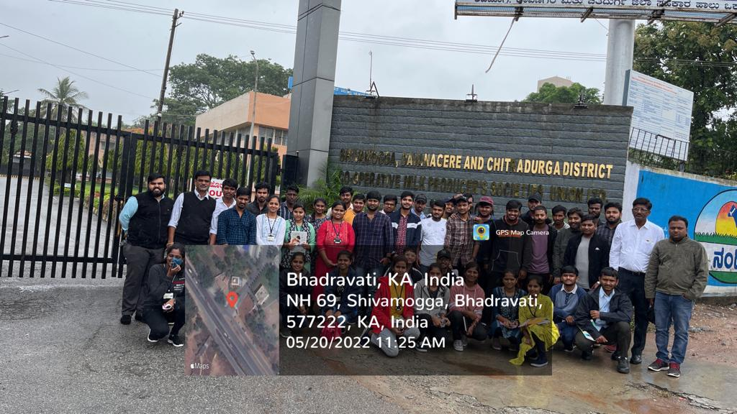
- Industrial visit for 6th and 8th semester students to Shivamogga, Davanagere and Chitradurga Co-operative Milk Union Limited (SHIMUL), Machenahalli, Shimogga.on 20th May 2022.
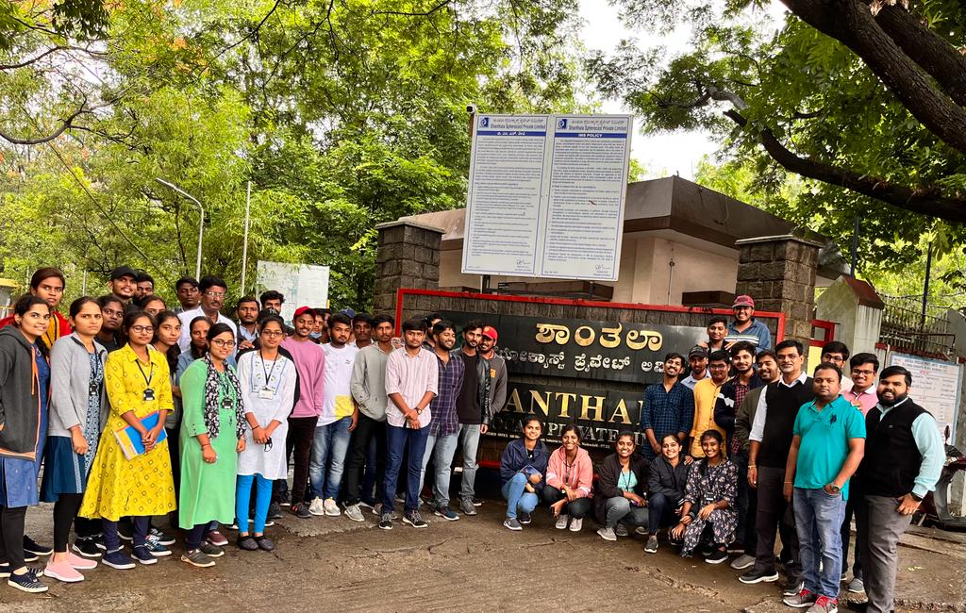
- 6th and 8th semester students Shanthala Spherocast Pvt. Ltd. Machenahalli, Shivamogga on 20-05-2022.

Election was held on 26rd September 2021 at 10:00 AM to nominate the office bearers for Association of Chemical Engineers for the year 2021-2022. Following Students were elected unanimously.
1. General Secretary – Sanketh (VII sem)
2. Joint Secretary – Pavan Kumar I B (VII sem)
3. Treasurer – Yash Raj Patil (V sem)
4. Cultural Secretary – Shrinivasa B H (VII sem)
5. Lady Representatives – Rekha Shenvi (VII sem) and Nidhi B U (V Sem)

- Students of III, V and VII semester invited all the teaching and non-teaching faculty of Chemical Engineering Department and celebrated the Teachers Day on 05th September 2022 at Perry Seminar Hall.
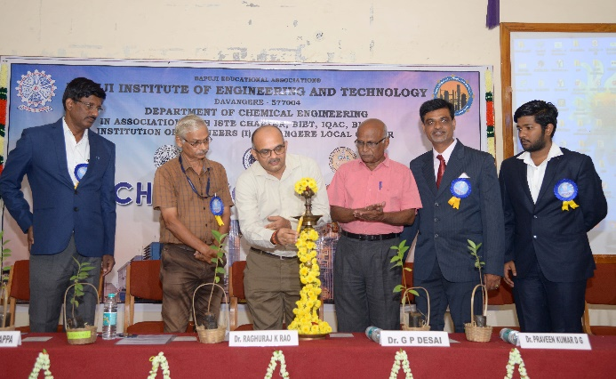
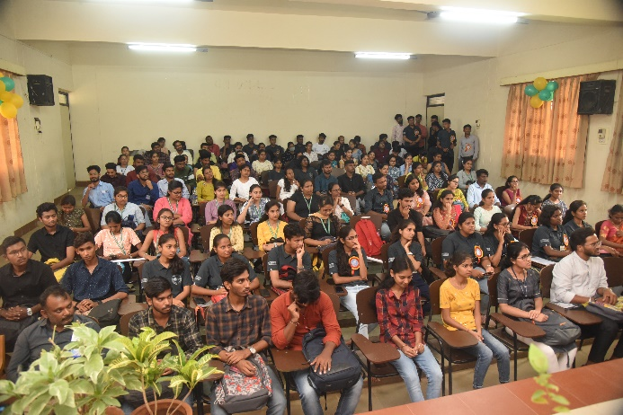
CHEMXCEL -2022 a national level student’s symposium was organized by department of chemical engineering on 29th June 2022. Dr. Raghuraj K Rao, MD AKXA-TECH Pvt. Ltd. Belagvi Inaugurated the function and Sri.Panchakshari S Guddad, Alumni of our department was the chief guest of the event. Dr. Raghuraj K Rao gave a talk on “Advances in Process Engineering”. Prof. Y Vrushabhendrappa, Director, BIET, Dr. H.B. Aravinda Principal, BIET, Dr. G.P Desai, Chairman IE(I) local center davangere, Dr. C. M Kalleshappa, Convener & HOD, Chemical Engineering, Dr. Praveen Kumar D.G., Organizing Secretary were present on this occasion.

FACULTY INTERACTION
- Ph.D viva-voice examination of Research scholar Mr. Praveen Kumar D G was held on 10th August 2019 in the Perry seminar hall of Department of Chemical Engineering, Dr. Umesh Hebbar Principal Scientist and Head Technology Transfer and pilot plant was the external examiner and Dr. Kalleshappa C M, Associate Prof. Dept. of Chemical Engineer was the internal Examiner.
- Dr. Praveen Kumar D G was invited as chief guest for Talent exhibition by Lalitha International public school, Davangere on 20th December 2019.
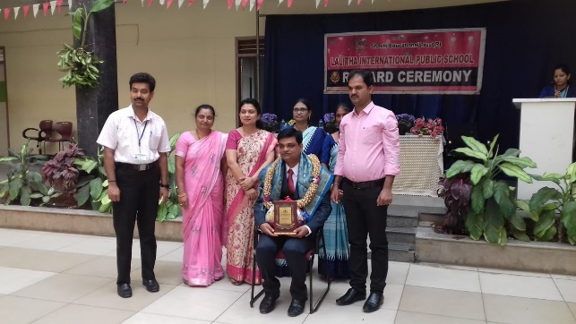
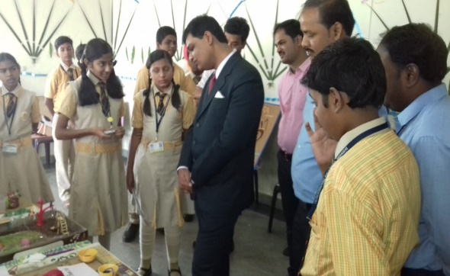

- Smt. Shashikala K J attended 5 days online FDP on "NBA and NAAC Accreditation Process" organized by IQAC M S Ramaiah Institute of Technology under AICTE Margdarshan scheme from 04th June to 8th June 2020.
- Smt. Shashikala K J attended a webinar on “Smart Irrigation using Internet of Things" jointly organized by department of civil engineering and computer science and engineering, G M Institute of Technology, Davangere on 15th June 2020.
- Smt. Shashikala K J attended 4 days live webinar on "Research Methodology and Data Analysis" organized by KSTA, Department of Science and Technology, Government of Karnataka Bengaluru held from 17th to 20th June 2020.
- Smt. Shashikala K J attended "Yoga for All" international yoga conference organized by Utshai Yoga Foundation on the occasion of 6th International day of yoga on 21st June 2020.
- Smt. Shashikala K J attended a webinar in Facebook live on "Women Rights under Constitution and Vishakha Guidelines on Sexual Harassment" organized by Women Cell, VTU Belagavi on 4th July 2020. Smt. Chethana Biraj, Advocate, High Court of Karnataka, Dharwad bench was the speaker.
- Dr. Praveen Kumar D G attended workshop on "How to Write Research Proposals" conducted by Bapuji Educational Association - Research and Development Cell at training and placement seminar hall, BIET Davangere on 28th July 2020.

STUDENT INTERACTION
- Students of V and VII sem participated in the one day workshop on E-step start-up boot-camp conducted by k-tech, innovative Karnataka, government of Karnataka, on 28th August 2019 held at BIET, Davangere.
- Dr. Praveen Kumar D G, Manoj B K, Varun C K, Yashraj S Patil, Faizal A H, participated in 3 day workshop on Recent advances in chemical science & Engineering organized by KSTA, DST, Government of Karnataka, Bengaluru from 5th to 7th September 2019.
- Akvil Rose K C, Shimran Sayed Yousuff, Pavan Kumar I B, Shrinivasa B H, participated in “Advitiya-19”, two-day National level student’s technical fest, organized by electrical & electronics department KLE Institute of Technology, Hubballi-30 from 20th to 21st September 2019.
- All IV sem students visited to Kurubarhalli and Kondajji to earn activity points from 2nd to 7th February 2020.
- Soundarya S K and Nidhi B U participated in XVI Karnataka State ISTE Students Convention themed as "Smart World through Innovative Future Technology" organized by K S Institute of Technology and Indian Society for Technical Education, Bengaluru on 22nd February 2020.
- Manoj B K, Rahul Kumar, Mallikarjun Hiremat, Sameet Patil, Amulya TM, Sahana H K, Nidhi B U and Seema K participated and presented papers in “BIOCHESS-2020”, national level students technical symposium, organized by Department of Biotechnology and Chemical Engineering, Siddaganga Institute of Technology, Tumakuru on 7th March 2019.
- Nidhi B U presented paper and secured II prize in "ALCHEMIST-2020" a national level technical symposium organized by Department of chemical engineering , KLE Dr. M S Sheshgiri College of Engineering and Technology, Belagavi on 16th June 2020.
- Prajwal E U completed a 21 hours of Mastery courses - Microsoft Excel, Word, Unlock Macros and VBA online on 18th June 2020 conducted by i Tech Sam Instructor and U Udemy.
- Prajwal E U completed a the COSHH Risk Assessor Certification course- online conducted by the International Association for Chemical Safety, the Knights of Safety on 24th June 2020.
- Aikya Rai M participated in the webinar on “Evolution of Bigdata" organized by Department of Information Science and Engineering, MVJ College of Engineering, Bengaluru on 27th June 2020.
- Kolli Chandana and Nidhi B U attended a webinar on Process Safety and Management by Mr. Vijay V Bhujle, senior VP-Technical at GVS Cibatec Pvt. Ltd. Organized by Indian Institute of Chemical Engineers, BMSCE Student Chapter on 10th July 2020.
- Sahana H K participated in National Level E-Quiz “Engineering Thermodynamics-2020" conducted by the Department of Chemical Engineering, Siddaganga Institute of Technology, Tumakuru from 14th to 15th July 2020.
- Aikya Rai M participated in online workshop on "Android App Development without Coding" conducted by Department of Computer Science and Engineering, Jain College of Engineering and Technology, Hubballi from 13th to 17th July 2020.
- Aikya Rai M undergone a training on "Android App Development Foundation" conducted by APPONIX on 20th July 2020.
- Sahana H K participated in National Level E-Quiz "Chemical Technology" conducted by the Department of Chemical Engineering, Siddaganga Institute of Technology, Tumakuru from 24th July 2020.

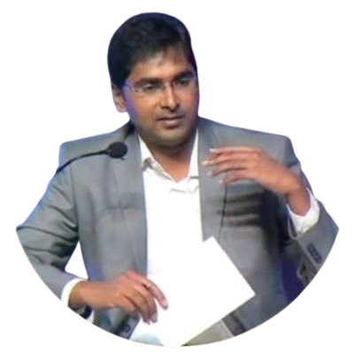
DISTINGUISHED ALUMNI
Dr. SATAKARNI MAKKAPATI – PRESIDENT
(CuraTeQ Biologics Pvt. Ltd. (a subsidiary of Aurobindo Pharma Ltd.)

Dr. Satakarni is a scientific leader effective at leading turnaround situations, formulating start-up strategies, and leading integrated biologics and plasma fractionation business units. He has involved in building up of a Biotech Organization from scratch brick by brick, managed investments, created strategy, and organized top-notch infrastructure. He has been listed as Eight Key Influencers in Biologics Manufacturing Industry in India for contributions to the sector, in 2013. Recognized as Top 30 executive MBAs for 2015 by Poets and Quants. He is a proud Alumnus of our department, completed his graduation in Chemical Engineering in the year 2002. He pursued his Ph.D from University of Manchester. He worked as Functional Lead of Cell Culture Process Development in Dr. Reddy’s Laboratories. He worked as Group Leader and Head of Mammalian Upstream Process Development and Pilot Plant Function in Hospira, Adelaide. He went on to pursue executive MBA from IMD Business School, Switzerland. He has served as Plant Head - Biopharma Operations and Site Engineering in Intas Pharmaceuticals, Ahmedabad. Later promoted as Sr. VP and Head - Biopharma and Celestial (plasma derived proteins) Biologics Business Divisions. Joined Aurobindo Pharma as President and Co-founder in the year 2016. Presently serving as President, CuraTeQ Biologics Pvt Ltd (a subsidiary of Aurobindo Pharma Ltd).
GRADUATES LIST 2018-2022
S.NO | USN | STUDENT NAME | EMAIL ID | CONTACT NO
1 | 4BD17CH030 | ABHISHEK R | abhir2069@gmail.com | 9901153794
2 | 4BD18CH001 | ABHISHEK T | tasva12345@gmail.com | 8861116560
3 | 4BD18CH002 | AIKYA RAI M | aikyarai09@gmail.com | 7034587761
4 | 4BD18CH003 | ALEENA BIJU | bijualeena1@gmail.com | 7022523903
5 | 4BD18CH004 | ANUSHA H N | anushahn136@gmail.com | 9535926700
6 | 4BD18CH006 | ASHA G L | ashaglingaraju@gmail.com | 9686195742
7 | 4BD18CH007 | CHAITRA | chaitramalagi2580@gmail.com | 8073919860
8 | 4BD18CH010 | KANTESH MARITAMMANAVAR | kanteshsm77@gmail.com | 6361260886
9 | 4BD18CH011 | KARAN V | krn9353798097@gmail.com | 9353798097
10 | 4BD18CH012 | LAXMISHEN AKKATANGERHAL | laxmishen@gmail.com | 9591203561
11 | 4BD18CH013 | NIKHITA H KUNTE | nikhitakunthe135@gmail.com | 6362752945
12 | 4BD18CH016 | PRAJWAL E U | prajwaleu@gmail.com | 9482675767
13 | 4BD18CH017 | PRAVEEN D BADIGER | badigerpraveen177@gmail.com | 9164008876
14 | 4BD18CH020 | SANKETH MAKANUR | sankethmakanur@gmail.com | 8277534231
15 | 4BD18CH021 | SHARANKUMAR V KUMARI | sharankumarvkumari@gmail.com | 8105814288
16 | 4BD18CH023 | SINCHANA G | sinchanagkaranth26@gmail.com | 9380676912
17 | 4BD18CH025 | ULLAS V | ullasdwaravati@gmail.com | 6360306276
18 | 4BD18CH026 | VEERAJ S B | veerajsb2000@gmail.com | 9844305131

GROUP PHOTO 2018-2022 BATCH
