**Department VISION &MISSION**

**Department of Chemical Engineering**

***Vision of the Department:-***

To train and generate efficient manpower required for effective management of core / allied industries, have a thrust for innovation, undertaking need based research who contributes to Global knowledge and wealth.

***Mission of the Department:-***

M1:To offer a quality and efficient undergraduate program in Chemical Engineering required for successful professional career.

M2: To produce graduates who have ability for creative research (thinking) and an urge for continued learning.

M3: To practice sustainability and promote ecofriendly processes which benefit the engineering profession and society.

**FDP/WORKSHOP ATTENDED**

1. Dr. C. M. Kalleshappa attended a webinar on “Outcome Based Education and Accreditation Programme” on 16-02-2021, organized by NBA, New Delhi in association with VTU, Belagavi.
2. Smt. Shashikala K. J. and Amarnath P. C. and Dr. Praveen Kumar D. G. attended a 3 day virtual workshop on “Future of Chemical Engineering” under TEQIP-III organized by Department of Chemical Engineering, Indian Institute of Technology, Dhanbad, Jharkhand, India from 19-03-2021 to 21-03-2021.
3. All the faculties of Department of Chemical Engineering attended a demo class on newly purchased Process Control and Instrumentation Lab equipment such as Multiprocess Trainer, Pressure Control Trainer, Temperature Control Trainer by Mr. Rajkaranth, Apex Innovations Pvt., Ltd., Sangli, Maharashtra,organized by Department of Chemical Engineering, on 24-03-2021.
4. Mr. Amarnath P. C. and Smt. Shashikala K. J. participated in FDP on “Blog-a-Than” organized by Department of CS &E, BIET Davangere.
5. All the faculties of of Chemical Engineering Department participated in 5-day workshop on “Biotechnology v/s Covid Challenges Opportunities and Ethics for the Research and BT Industries” organized by Department of Biotechnology, BIET, Davangere, held virtually between 24th to 28thMay 2021.
6. All the faculty members of the department have attended interactive session on National Assessment and Accreditation Council (NAAC) Prospects, Procedures and Process delivered by Dr. R. C. Hiremath, Former Principal, KLE, Bengaluru, on 22nd July 2021 at SSM Cultural Center, BIET.
7. 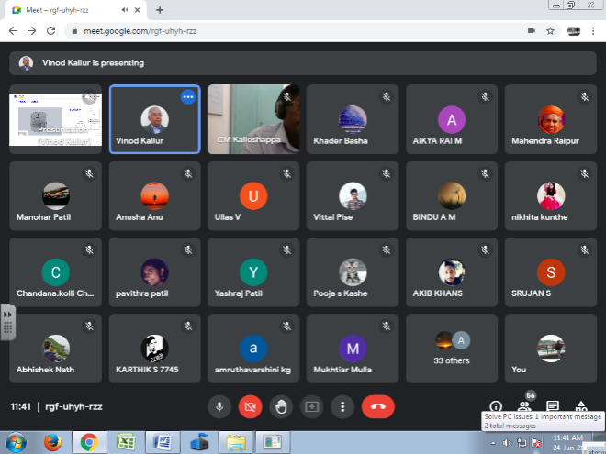Dr. Praveen Kumar D.G. participated and successfully completed 5 day online FDP on the theme “Including Universal Human Values in Technical Education” organized by AICTE from 26th July 2021 to 30th July 2021.
8. Dr. C.M. Kalleshappa attended workshop on “Assessment Reforms and Practices under NEP-2020” on 29-10-21 at Dr. APJ Abdul Kalam Auditorium, VTU, Belgaum. Prof. Gopal Krishna Joshi, Executive Director at Karnataka State Higher Education Council, GOK was resource person.
9. Dr. C.M.Kalleshappa, Dr. G.P. Desai, Dr. Praveen Kumar D.G., Mr. Amarnath P.C., Smt. Shashikala K.J. and Mr. Srinidhi R. Kulkarni attended 2 days workshop on “Implementation of NEP on Blended Mode” held at SSM Cultural Center, Bapuji Institute of Engineering Technology, Davangere.

**FDP/WORKSHOP ORGANIZED**

1. A webinar on “Computational Fluid Dynamics (CFD)” was organized by Department of Chemical Engineering in association with ISTE students chapter BIET and IEI, Davangere Local center on Thursday 24th June 2021. Dr. Vinod Kallur, Professor & Head Dept. of Chemical Engineering, RVCE, Bengaluru was the speaker.
2. Final year students for the year 2020-21, presented their project proposals for Financial Assistance for innovative projects by VTU, Belagavi to the selection committee through online. Karthik H. and team – Production of Biodiesel from waste cooking oil and Amulya T.M. and team – Extraction of silver from used X-ray films projects were selected for financial assistance.
3. A webinar on “Environment Management at JSW Steel Ltd.,” was organized by Department of Chemical Engineering in association with ISTE students chapter,BIET and IEI, Davangere Local center on 01-07-2021. Dr. R. T. Srinivas Rao, General Manager from JSW Torangallu was the chief resource person.

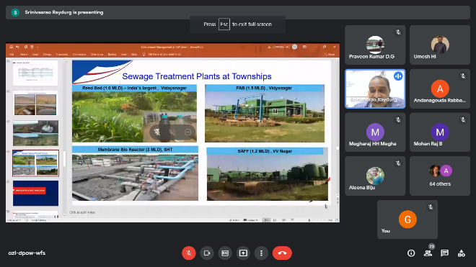

1. 5 day training workshop on UNISIM process simulation software for Chemical Engineering students was conducted. Mr. BabuKannan Shankar, Honey Well Chennai gave hands on training from 20th December to 24th December 2021.

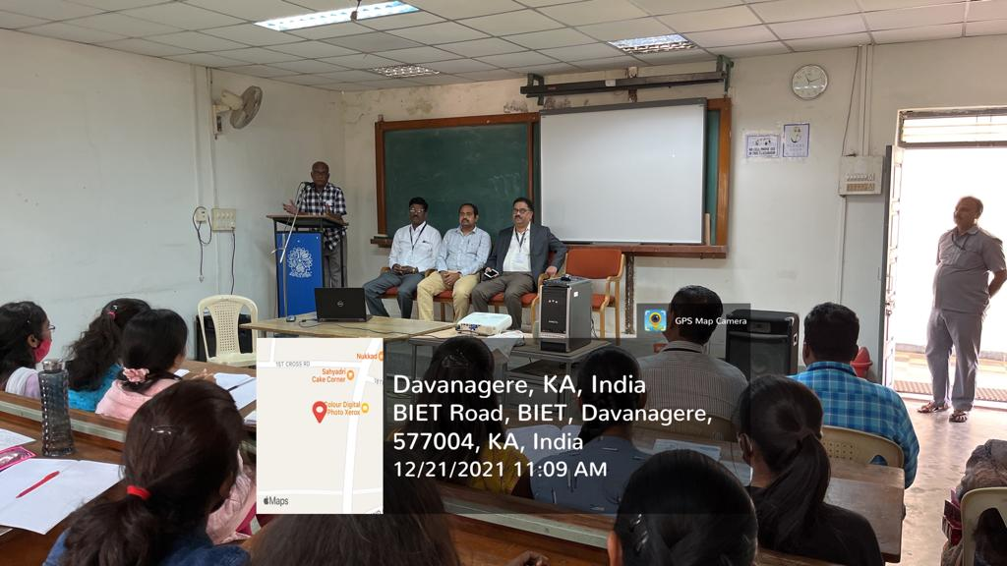

**INVITED LECTURES DELIVERED by Faculty**

1. Dr. C. M. Kalleshappa, HOD, delivered a talk on Chemical Engineering Department at Student Induction Program-2021 on 09-06-2021.

**EVENTS ORGANIZED in Department**

1. Department of Chemical Engineering organized a “Virtual Parents Meet” on 02-01-2021. About 35 Parents were participated in the event.
2. Inauguration of forum activities and welcome to 2nd year students was conducted on 12-08-2021. Farewell to final year students was conducted on 12-08-2021.
3. Final Year Project Group Students participated in “NIRMANA 1.0 –Virtual Project Exhibition -2021” held at BIET on 13-08-2021. Nirmana Virtual Project Exhibition was inaugurated by Sreenath Kalamdani, GDM, Mercedes Benz, Bangalore and Kshitij Basavaraj, Director, PSK Pharma, Harihara was expert to evaluate the projects for Chemical Engineering.
4. Open house project exhibition “Technovation-21” was held at SSM Auditorium on 04-09-2021. Three projects from chemical engineering Department were displayed.

**PROJECTS SANCTIONED BY KSCST/ or any other notable student projects**

1. Dr. Praveen Kumar D. G., and Dr. C. M. Kalleshappa, received the funding from NAIN for the project on “Super Critical Extraction of Oleo Resins from Chillies”.
2. Soundarys S. K., Geetanjali B. S., Pooja N.Sand Kolli Chandana, received the funding from institute for the project entitled “Extraction of Tamarind Seed Oil as Potential Alternate Fuel for Sustainable Green Environment” guided by Dr. C.M Kalleshappa and Amarnath P C.
3. Chandan S K, Karthik H H, Rahul Kumar A S and Rithik R , received the funding from VTU for the project entitled “Production of Biodiesel from Waste Cooking Oil”guided by Dr. Praveen Kumar D G and Dr. C M Kalleshappa.
4. Amulya T M and Sahana H K received the funding from VTU for the project entitled “Extraction of Silver from used X-ray Films” guided by Shashikala K J.

**STUDENTS ACTIVITIES/programs organized/Attended**

1. Inauguration of forum activities 2021-2022 and welcome to 3rd semester students was held at seminar hall of Chemical Engineering Department. Shri Santosh Kumar Guddad, Senior Director, Plant Lead for Monoclonal Antibody Facility, Biocon Biologics Ltd., Bangalore was the chief guest and addressed the students. Prof. Y Vrushabhendrappa, Director, Dr. H.B. Aravinda, Principal, Dr. C.M. Kalleshappa, HOD, Dr. G.P. Desai Professor were present.
2. Aumni, Mr. Basavanagowda, 2018 batch output student presented a seminar on "Resume Writing and Information on Job Sites” to all the students of Chemical Engineering.
3. Students of Chemical Engineering and faculty members participated in oath taking on account of constitution day on 26-11-21 conducted by NSS and ISTE, BIET chapter at Chemical Engineering Department BIET.
4. Students of 5th& 3rd semester BE participated in “Kannada Rajyotsava” programme organized by Electrical and Electronics Department of BIET. Hemanth K.P. of 3rd sem won I prize and Amruthavarshini of 5th sem won III prize.
5. Ph.D candidate Smt. Shashikala K.J. application was approved under guidance of Dr. C.M. Kalleshappa and Dr. G.P. Desai by Principal office.
6. Ph.D candidate Mr. Shivakumar application was approved under guidance of Dr. G.P. Desai by Principal office.

**PAPER PRESENTED /PUBLISHED by faculty**

1. Dr. Praveen Kumar D.G. with co-authors Dr. C. M. Kalleshappa, Mr. Amarnath P.C. and Smt. Shashikala K.J. published a paper entitled “Bagasse Fly Ash as an Effective Adsorbent: Evaluation of Adsorptive Characteristics for 4-Nitro Aniline Removal” in International Journal for Modern Trends in Science and Technology, volume 7, Issue 05, May 2021, ISSN: 2455-3778.
2. Dr. G P Desai published a paper entitled “CFD Combustion Simulations and Experiments on the Blended Biodiesel Two-Phase Engine Flows”,Computational Fluid Dynamics, Open Access Peer-Reviewed Chapter - Online First,DOI: 10.5772/intechopen.102088.
3. Dr. G P Desai published a paper entitled “Experimental Investigation on Thermal Conductivity And ThermalDegradation Of Honge Oil Methyl Ester With B-20 Blend”, Journal of Thermal Engineering,Vol. 7, No. 7, pp. 1604–1613, November, 2021.DOI: 10.14744/jten.2021.0006.
4. Dr. G P Desai published a paper entitled “Thermal Characterizationof Dairy Washed Scum Methyl Ester and Its B-20 Blend for CombustionApplications”,International Journal of Ambient Energy,https://doi.org/10.1080/01430750.2021.1909651,published online: 08 Apr 2021.

**PLACEMENT DETAILS**

1. Guruprasad B., was placed in Cargill India Ltd., Harihar
2. Manoj B.K., was placed in Anthem Biosciences, Bangalore.
3. Rahul Kumar A. S., was placed in Biocon Limited, Bangalore.
4. Sahana H. K., and Sammed Patilwere placed in BASF India Limited Mangalore.
5. Rithik R., was placed in Cipla Limited Bangalore.
6. Pooja N. S., and Nandeesh D. R., were placed in Biocon Limited, Bangalore.
7. Khader Basha M., was placed in Anthem Biosciences, Bangalore.
8. Yashraj S Patiland Soundarya S. K., were placed in AT&S India Pvt Limited, Mysore.
9. Ananda Rupewas placed in Akxa Tech Pvt. Limited, Kollapur, Maharashtra.
10. Chandan S. K., was placed in PAI & PAI Chemicals
11. Abhishek Nath was placed inAT & S Mysore.
12. Amulya G. V., was placed in Prakruti Products Limited, Tumkur.
13. Balaji Jadhav and Rakesh G., were placed in Cipla Limited, Bangalore.
14. Akib Khan was placed in MSN Laboratories Limited, Hyderabad.
15. Geetanjali B., was placed inCMTI, Bangalore.
16. Karthik H. H., was placed inBal Pharma limited, Bangalore.
17. Kolli Chandana was placed in iLensys Technologies, Hyderabad.
18. Albin Jacob and Sai Shankar P., were placed in RKM Power Gen. Pvt. Ltd., Chattisgarh.

**STUDENTS APPLIED FOR B.E. HONOURS**

1. Amruthavarshini, Pavithra, Manohar V Patil, Kavya B and Shruthi K.M. of 5th semester Chemical Engineering Department applied for B.E. Honours to VTU.

**UNIVERSITY WORK carried by Faculty**

1. Dr. C. M. Kalleshappa was Chairman BOE and Member BOS for Chemical /Petrochemical Board at VTU for the academic year 2020-21.
2. Dr. G. P. Desai was member BOS for Chemical /Petrochemical Board at VTU the academic year 2020-21.

**INSTITUTE RESPONSIBILITIES**

1. Dr. C. M. Kalleshappa has taken charge as ISTE student Chapter and faculty advisor with effect from 03-02-2021.

**­­­­­­­­­­­­­­­­­­­­­­­­­­­­­­­­**