BAPUJI EDUCATIONAL ASSOCIATION (REGD.)
BAPUJI INSTITUTE OF ENGINEERING & TECHNOLOGY, DAVANGERE-4
DEPARTMENT OF COMPUTER SCIENCE & ENGINEERING

Result Analysis of 5th semester for the academic year 2021-22.
Subject-wise result of the 5th semester for the academic year 2021-22.

Sl. No | Subject Code | Name of the Teacher | Section | Total Strength | Fail | Pass | Pass  Percentage
1 | 18CS51/17cs51 | Prof. RAGHU B.R | A | 72 | 1 | 71 | 98.6%
 |  | Prof. Naseer R | B | 70 | 0 | 70 | 100%
2 | 18CS52/15cs52 | Prof. ARUN KUMAR G.H(AGH) | A | 72 | 3 | 69 | 95.83%
 |  | Prof. SANTOSH K. C | B | 70 | 0 | 70 | 100%
3 | 18CS53/15CS53/17CS53 | Prof. SHRYAVANI K | A | 72 | 6 | 66 | 91.6%
 |  | Prof. RACHANA S | B | 70 | 2 | 68 | 97.14%
4 | 18CS54 | Prof. S.B MALLIKARJUNA | A | 72 | 5 | 67 | 93%
 |  | Dr. CHETANA PRAKASH | B | 70 | 2 | 68 | 97.14%
5 | 18CS55 | Prof. PREETHI B | A | 72 | 4 | 68 | 94.4%
 |  | Prof. RAGHU B.R | B | 70 | 5 | 65 | 92.85%
6 | 18CS56 | Dr. PRADEEP N | A | 72 | 7 | 65 | 90.27%
 |  | Dr. ASHOKA K | B | 70 | 5 | 65 | 92.85%
7 | 18CSL57 | Prof. ARUN KUMAR G.H | A | 72 | 0 | 72 | 100%
 |  | Prof. SANTOSH K. C | B | 70 | 0 | 70 | 100%
8 | 18CSL58 | Prof. SHRYAVANI K | A | 72 | 0 | 72 | 100%
 |  | Prof. RACHANA S | B | 70 | 0 | 70 | 100%
9 | 18CIV59 | Prof. SHAHABAZ HAKKIM | A | 72 | 0 | 72 | 100%
 |  |  | B | 70 | 0 | 70 | 100%

Overall result of the 5th semester for the academic year 2021-22.

Sl.no | Branch | No. Of Candidates Appeared | Failed | FC | FCD | PASS | Percentage
1 | CS&E | 141 | 25 | 24 | 34 | 116 | 82.3%

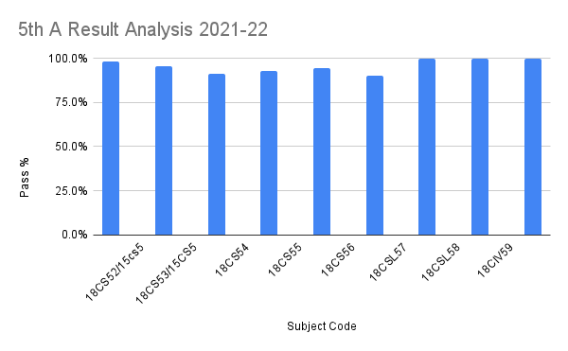

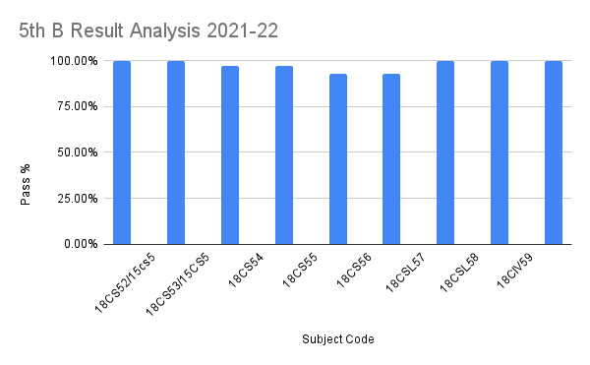

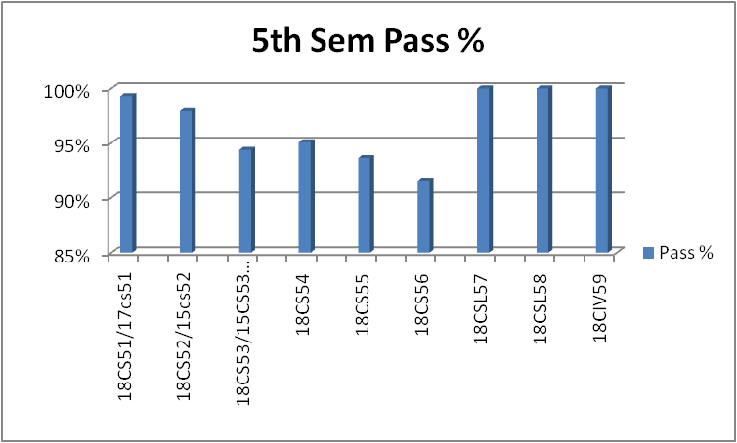

Program Coordinator PRINCIPAL

