Funny Cricket
The event "Funny Cricket" was organized by the Department of Information Science & Engineering and the Department of Computer Science & Business Systems, in association with the IEEE Student Branch. Originally planned to start from 27th December, the event kicked off on 3rd January 2024, and continued for a month. It took place at the football ground of BIET, where matches were scheduled daily after 4 PM. Despite the challenge of scheduling matches due to the large number of teams, the event garnered significant participation and enthusiasm from both participants and spectators.
One of the unique aspects of this event was the team composition, with each team comprising 4 boys and 4 girls. This not only added an element of inclusivity but also contributed to the fun and excitement of the matches. The event featured several funny rules that kept the participants and spectators entertained throughout.
The event was inaugurated by the HODs of the Information Science Department and the Computer Science & Business Systems Department, along with the sports coordinator of BIET, Prof. Kalleshappa. Their presence and support added to the excitement of the event and motivated the participants.
To encourage more participation, the registration fee for each team was kept at just Rs. 100, making it accessible to students from all backgrounds. This strategy proved to be successful, as evidenced by the large number of teams that registered for the event.
After a month of thrilling matches and memorable moments, the event concluded with a grand prize distribution ceremony. Prizes were awarded to the winning team, runners-up, best batsman, and best bowler. The prizes were presented by the HOD of the ISE department, Dr. Poornima B, and the HOD of CSBS, Dr. Vinutha H P, adding prestige to the awards.
The success of the event was a result of the hard work and dedication of the entire IEEE team, who worked tirelessly to ensure that everything ran smoothly. The event was coordinated by Prof. Puneeth B H, IEEE Branch Counselor, whose leadership and guidance were instrumental in the event's success.
In conclusion, "Funny Cricket" was not just a sporting event but a celebration of unity, diversity, and friendship. It brought together students from different backgrounds and departments, united by their love for cricket and their spirit of fun and sportsmanship.

Glimpses of event
Inauguration
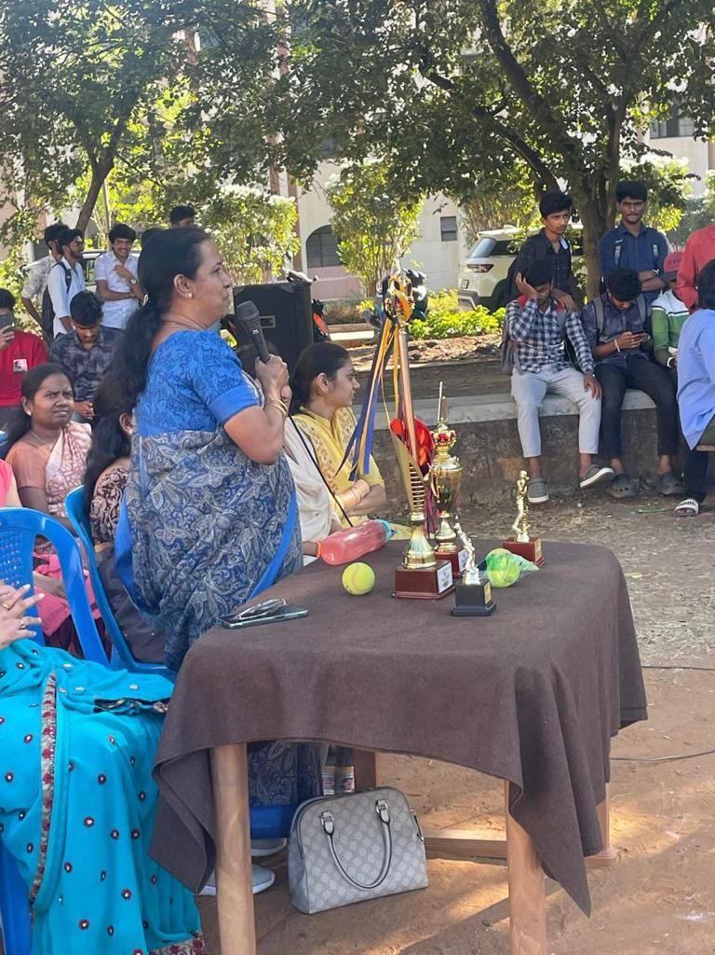
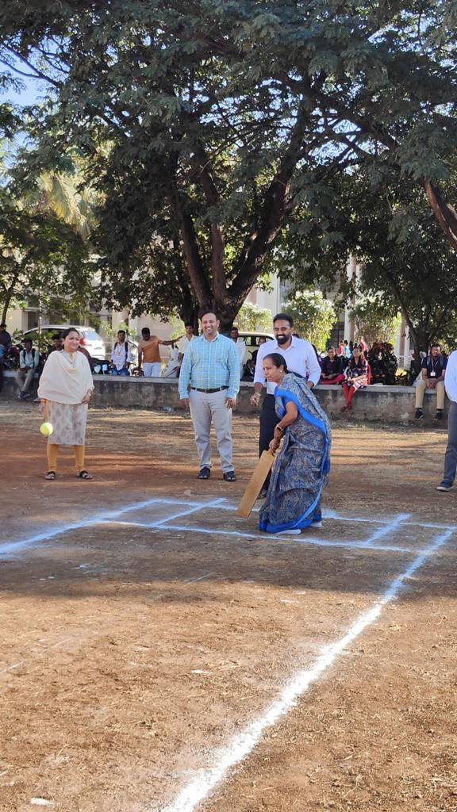
Match Day
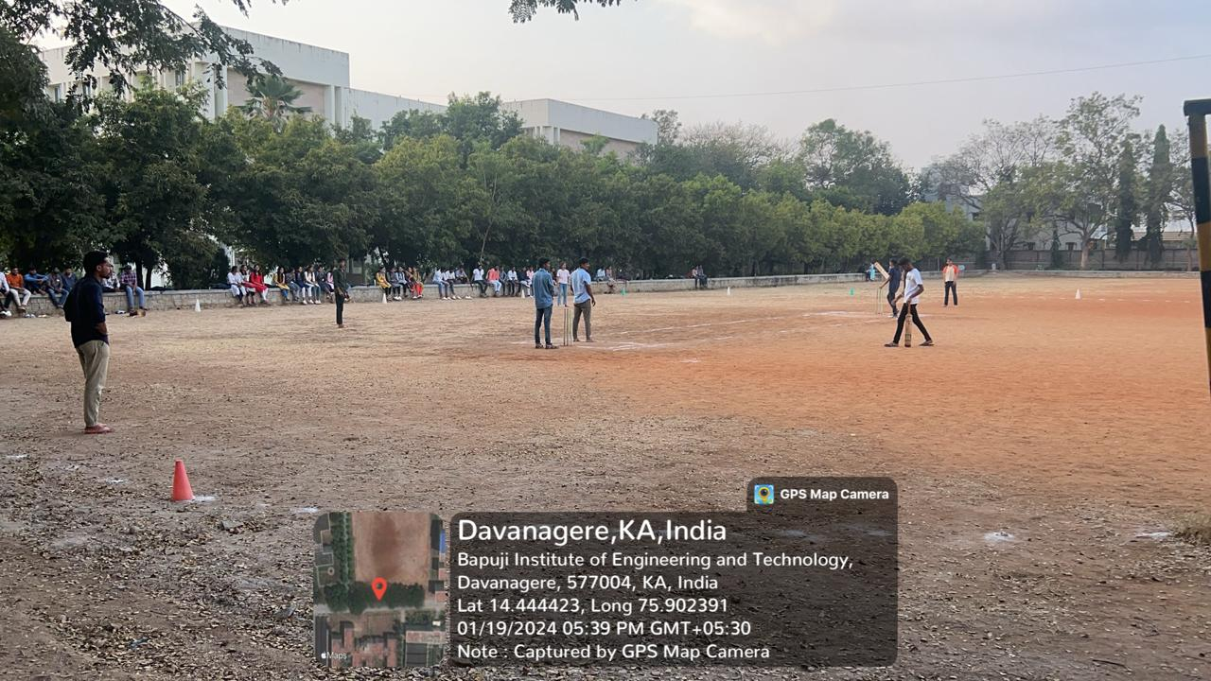
Prizes
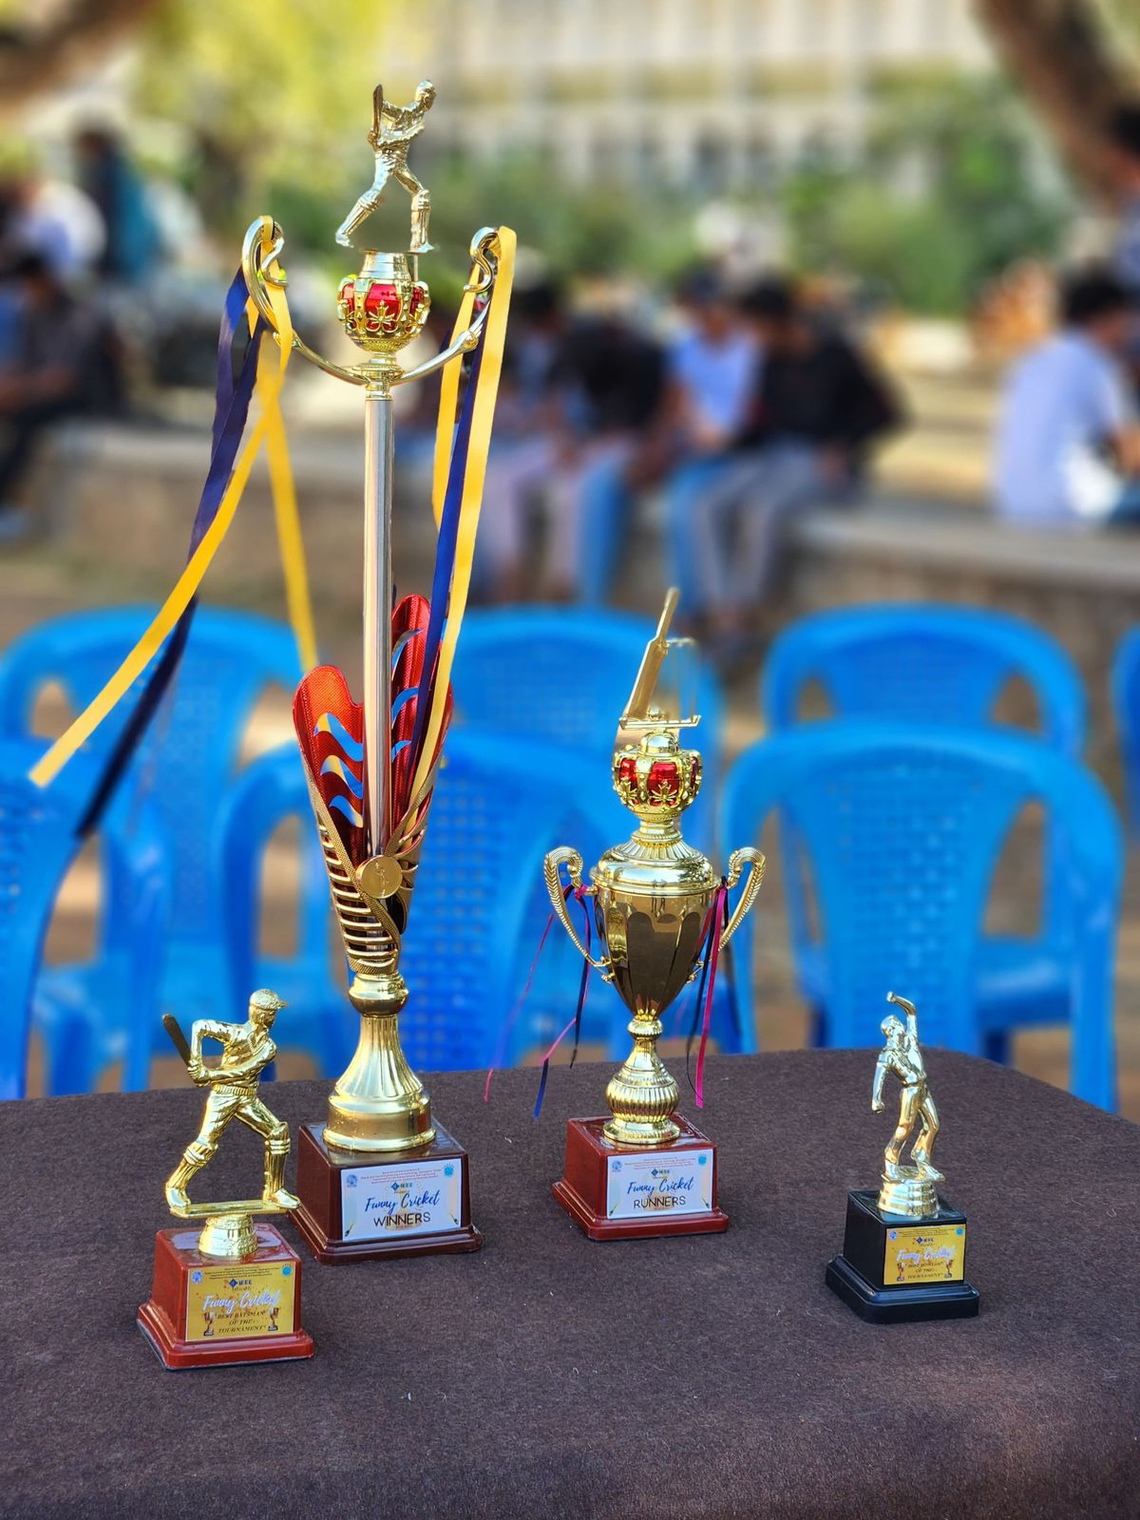

Winners
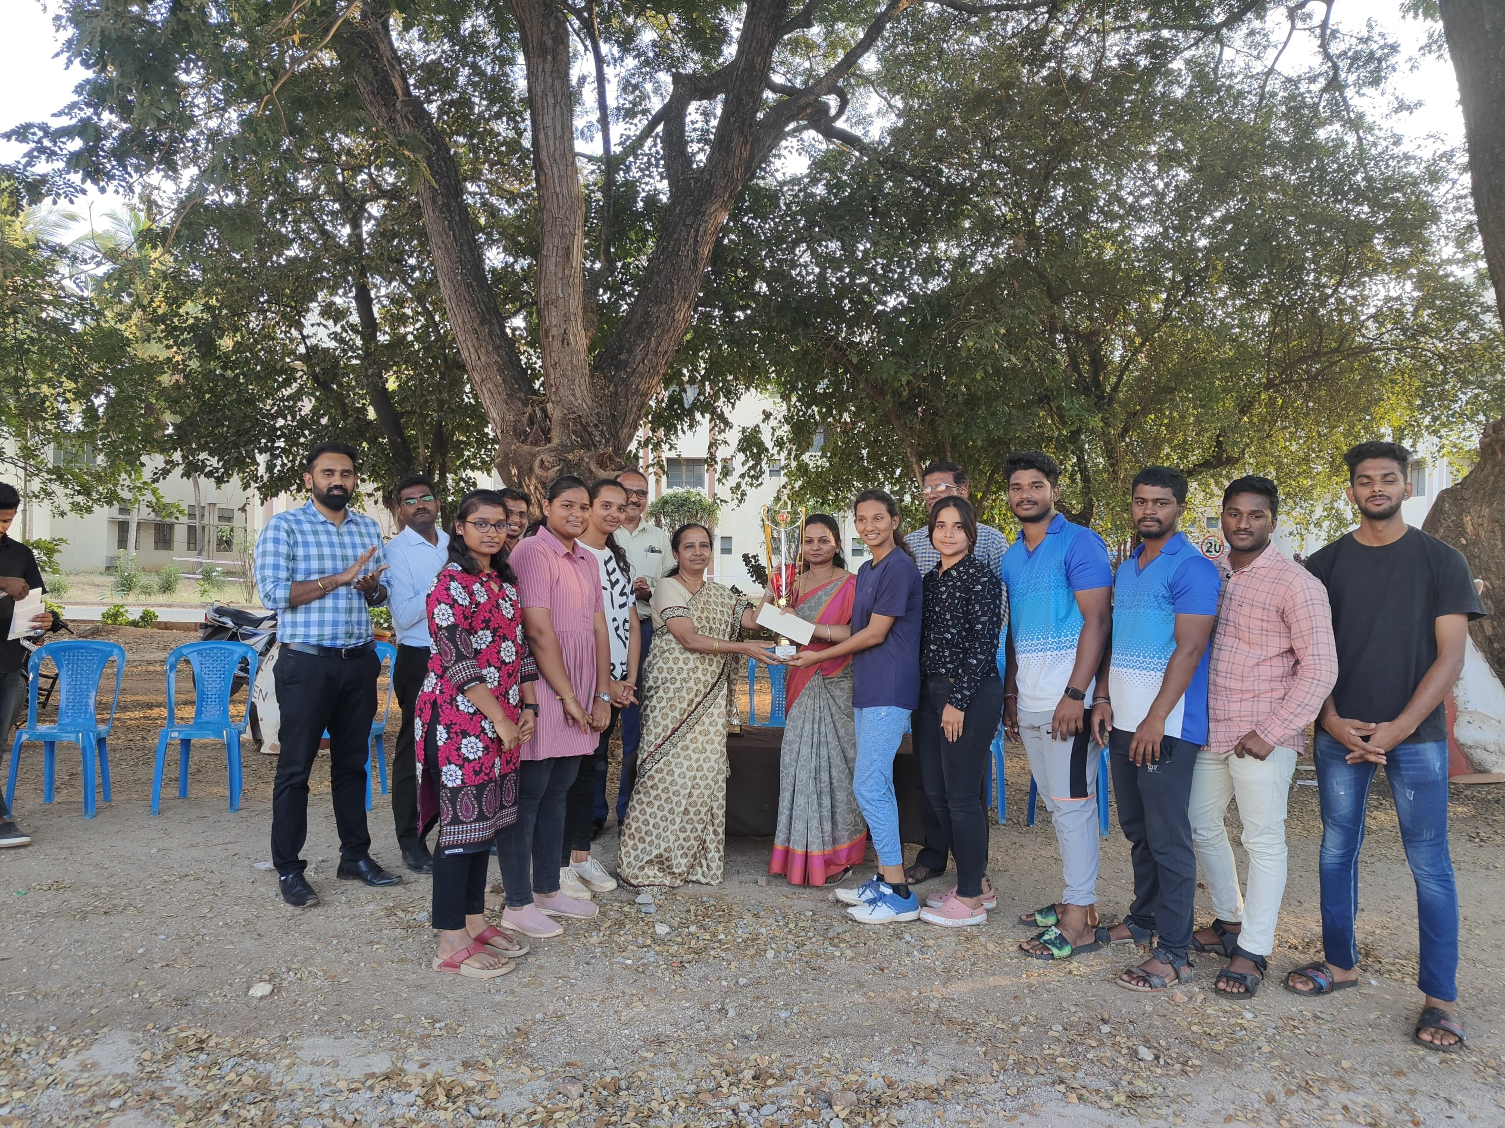
Runners
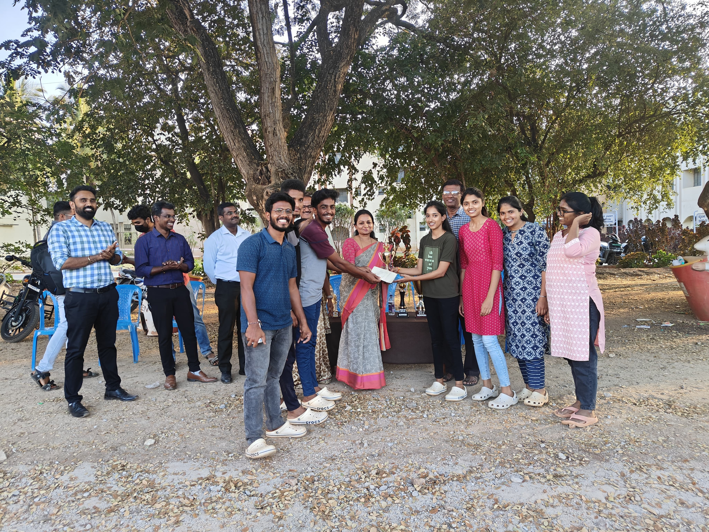

Event Coordinator Program Coordinator

