Mrs. Ramya Annigere
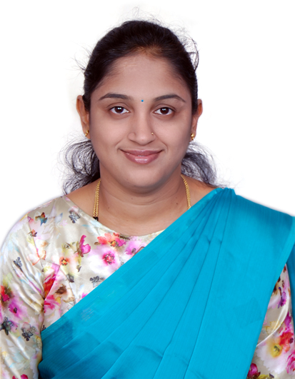
Assistant Professor
Department of E&IE BIET, Davangere
[annigere.ramya@gmail.com]
Work Experience: 2.5 Years
- Worked for Philips Electronics India Ltd. as a consultant software engineer from 1st August 2008 to 25th January 2009.
- Worked as a lecturer in BIET from 1st February 2009 to 30th April 2010.
- Currently Working as Assistant Professor in BIET Davangere from 2nd November 2020.

Educational Qualification:
- M.Tech [Digital Electronics] from G M Institute of Engineering and Technology, Davangere, 2016.
- B.E [Electronics and Instrumentation] from University BDT College of Engineering, Kuvempu University, 2008.
Awards:
- Awarded as University 1st Rank holder of Electronics and Instrumentation Engineering from Kuvempu University, 2008.
Core Subjects Taught:
Digital Logic Design, Lasers and Optical Instrumentation, Electronics Instrumentation and Measurements
Publications:
Presented the paper in National Conference on “Recent trends in Communication and Computing” (NCRTCC-16).
Webinars/FDP’s Attended:
- Webinar on “Remote Lab Platform for Hardware Circuit Experiments”, organized by Dept. of E&CE, BIET, Davangere on 10 Nov 2020.
- Attended Lecture Series conducted by R&D cell BIET, Davangere from 19-11-2020 to 26-11-2020.
- Attended Online FDP on "Control Systems & Sensors Technology" from 2021-1-19 to 2021-1-23 at Manipal Institute of Technology.
- Webinar on “Employability Skill for Women Empowerment in the Changing Environment”, organized by VTU, Women Cell on 5-02-2021.

